

**June 2022**

# **Key Features added to Benefitter!**

### Rate-up information

When a level funded underwriting quote is returned, we now tell you via email the percentage increase of the rate (based on the EE rate of the lowest priced plan). This allows you to quickly know if there is a large price difference that may affect your choice of plans. For preliminary underwriting quotes, we compare the quote to the illustrative (not underwritten) rate. For final underwritten quote, we compare those to the preliminary underwritten quote. Just review the “quote received” email, and you will see the rate-up percentage.

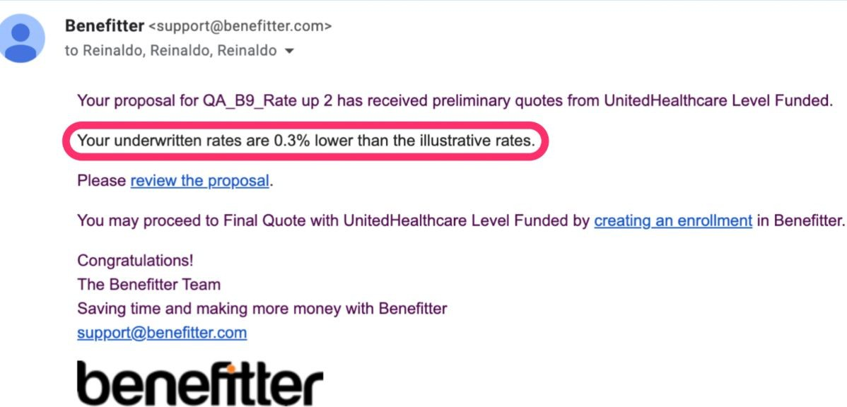

### Link to UHC eServices after a Level Funded group is installed

Whenever a UHC Level Funded group is installed via Benefitter, we now display a link in the persistent header to UHC eServices, to help you view more information about the group or make changes.

### Performance Improvements for Larger Groups

We made several performance improvements that significantly improve the speed for larger sized groups. The company profile page is now up to 50 times faster, the enrollment pages are up to 10 times faster, the proposal pages are up to 8 times faster, and the census is up to 5 times faster.

# **Resolved Issues and Other Updates**

* Changed Arkansas level funded minimum enrollment threshold to 5 for effective dates of 5/1/22 through 12/1/22.
* Changed Maryland census underwriting settings to 10 enrolling employees starting with 5/1 effective dates.
* Changed West Virginia census underwriting setting to 15 employees starting with 6/1/22 and later effective dates.
* Changed PDL link for Texas to point to parent listings rather than Essential PDL page.
* Employee applications were being required for declining employees at preliminary underwriting step.
* Employee applications were incorrectly being required for certain Texas claims groups.
* Groups were allowed to submit to preliminary underwriting with missing required information.

**Contact Benefitter Customer Support**

*Copyright © 2022 Benefitter. All rights reserved.*

## You are receiving this email because you expressed interest in Benefitter.

Benefitter 9151 Boulevard 26

North Richland, TX 76180

Want to change how you receive these emails?

You can update your preferences or unsubscribe from this list.