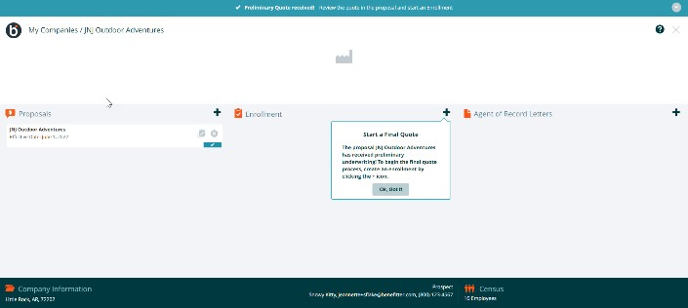 | Create the Enrollment  - In the enrollment section on the company homepage, click on the + icon  - Select a proposal to use to create the enrollment
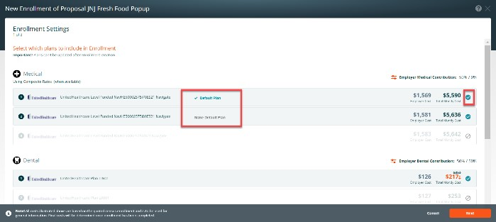 | Enrollment Settings Page 1 of 3  Add plans to the enrollment  - Select the plans to include in the enrollment by clicking on the + icon  - Plans cannot be updated after enrollment creation  - If you have more than one medical plan in the enrollment, click on the make default plan link to choose a different default plan.  Click Next to proceed to page 2
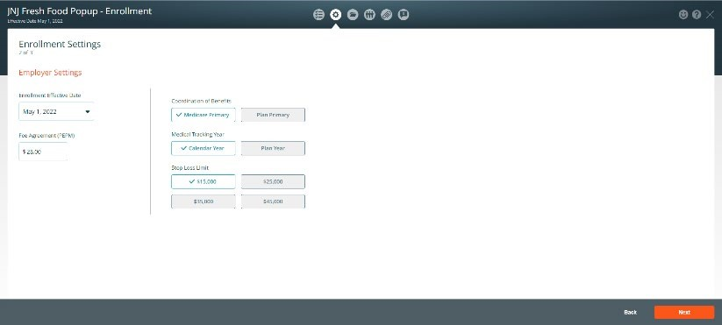 | Enrollment Settings Page 2 of 3  Employer Settings  - Enrollment Effective Date - Make sure the enrollment effective date and the proposal effective date are the same  - Fee Agreement (PEPM)  - Coordination of Benefits  - Medical Tracking Year  - Stop Loss Limit Press next  Important! Updating settings may impact employee costs and plan availability. If you intend to make changes to these settings, it is recommended that you update the settings in the Proposal and re-submit it for underwriting prior to making employee plan elections

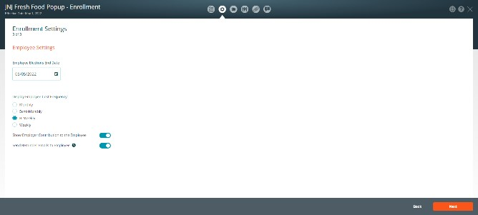 | Enrollment Settings screen 3 of 3  Employee Settings  - Choose a deadline for employee elections  - Select the period for showing employee costs (monthly, semimonthly, bi-weekly, weekly)  - If desired, turn off the Employer Contribution toggle to hide the contribution amount from employees  - Use the Reminder Emails toggle to activate follow up emails for  employee elections  Press Save
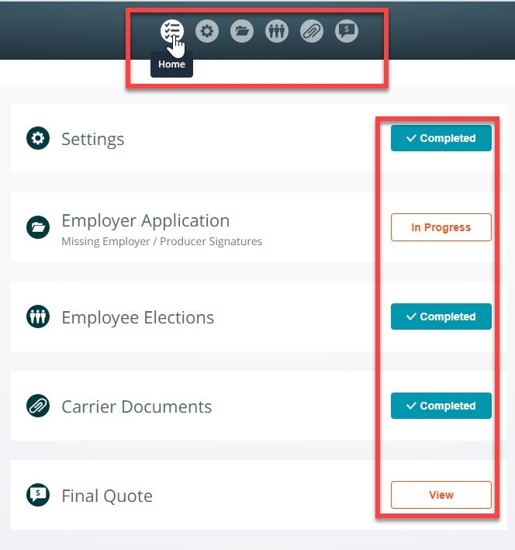 | Enrollment Checklist  The enrollment checklist guides you through the All-Savers enrollment processes  - To access the checklist items, click on the icons located at the center top of the page (Home, Settings, Employer Application, Employee Elections,  Carrier Documents, or Final Quote)  - Or click on the button on the checklist items to complete the enrollment steps  - The Submit Final Quote Application button will be disabled until all the required steps are completed
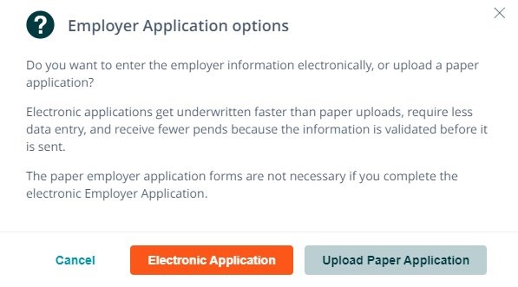 | Employer Application Options  - When you click on the Employer Application checklist item or icon, the system will display a message which advises that you can enter the employer information electronically or upload a paper application.  - The paper employer application forms are not necessary if you complete the electronic Employer Application

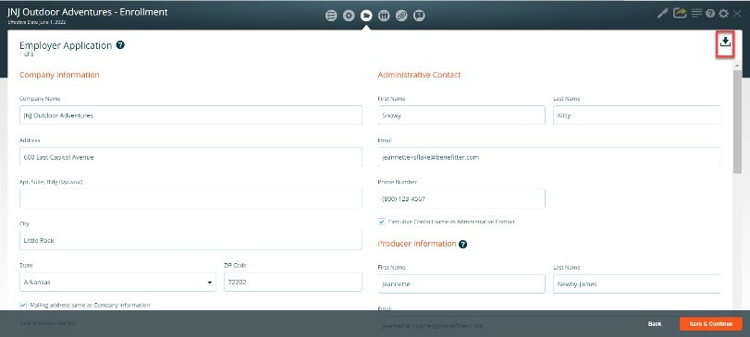 | The Employer Application streamlines four All Savers enrollment documents (Employer Application, Excess Loss  Application, Commissions Billing and Collections Agreement, New York Surcharge Form) into five screens:  - Employer and Agent Information  - Eligibility and Plan Selection  - Eligibility for Medical Coverage  - Payment  - New York Public Goods Pool
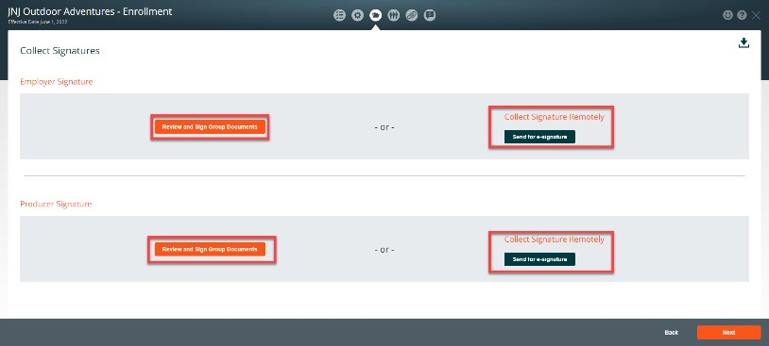 | Collect Employer & Producer Signatures  - The Collect Signatures section can be accessed once the Employer Application section is completed  - You can collect signatures in person (in the Benefitter interface) or by sending an email to collect them remotely
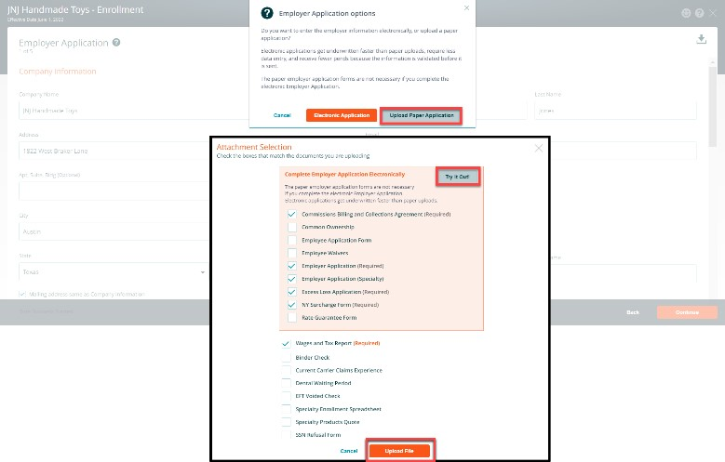 | Employer Application - Upload Paper  Application  - If you choose to upload the paper application, click on the Upload Paper Application button  - On the Attachment Selection, click on the checkbox next to the documents that you will be uploading  - Click on the upload files button and choose the documents on your computer to add to the enrollment
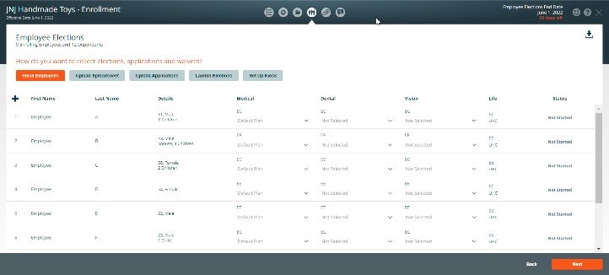 | Employee Elections - Choose from the options below to collect employee elections

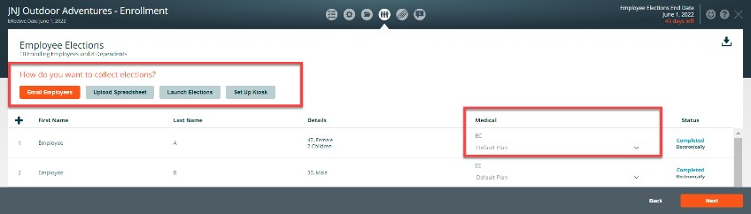 |  | Email Employees-Send employees an invite to complete a mobile-friendly enrollment. On the employee notification page, check the names of employees that you are inviting to complete their applications electronically
Up
Download the enrollment spreadsheet by clicking, Download Enrollment Spreadsheet. This spreadsheet is pre-populated with the census data you have already collected. All the employees on the census are included in this file. Note: you can upload the employee election scenario spreadsheet, if applicable.
 |  | o | Fill in each employee’s selected tiers, plans, and additional enrollment information and save the spreadsheet. Click the Upload Enrollment Spreadsheet button and upload the file
 |  | o | Fill in plan selections and missing information on the provided spreadsheet and upload the document
 | • | Upload Applications - (All Savers groups only) On the employee election page, click on the download indicator to download a copy of employee application o Attach a copy of the blank application to an email and send it to the employer/employees. When you receive the completed documents. Click on the upload application button and upload the completed applications.
 | • | Launch Elections - access an employee’s enrollment directly to walk the employee through completing the enrollment.
 | • | Kiosk - Download access codes pdf and set up a kiosk
 | • | Select plans/enroll group directly on the employee elections page.

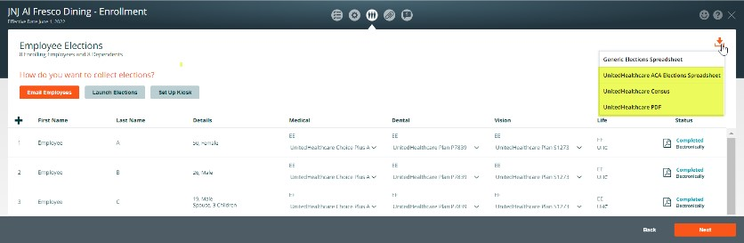  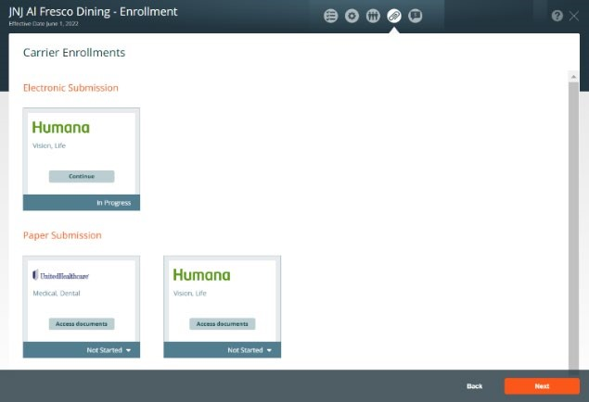 | Process Carrier Enrollment(s) - Click on Communication & Documents icon to access:  Paper Submissions  - Export employee information  - Elections spreadsheet download  (UHC, etc.)  - UHC Census pdf  - UHC Employee Applications  - Download Enrollment (Employer Group Application, etc.)  Electronic Submission - Humana  - Start Group Application  - Receive Group id  - Confirm Final Quote  - Application Confirmation  - Enrollment Processing  - Group Installation  - Post Installation (Download Member ID spreadsheet,  Employer Group Application)
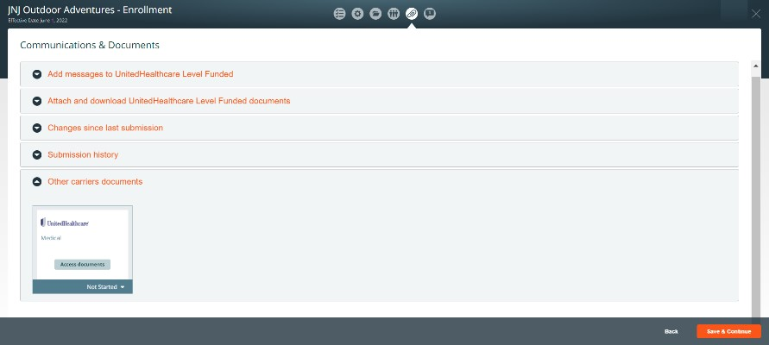 | Communications & Document checklist Click on the paper clip icon to:  - Send a message to the UHC Level Funded staff to discuss policies and procedures  - Attach/Download UHC Level Funded documents  - Review changes since last submission  - Review submission history  - Access other carrier documents
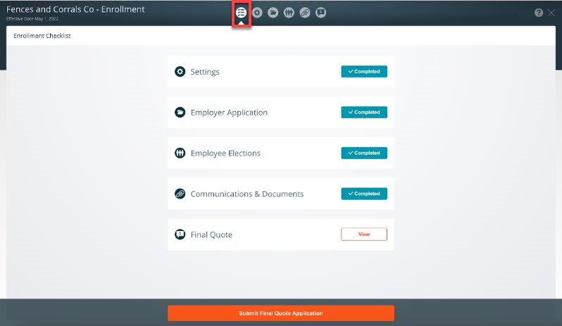 | Submit Final Quote Application  - When the (settings, employer application, employee elections,  communication & document) checklist items are set to completed  - Click the Submit Final Quote Application button at the bottom  of the checklist page

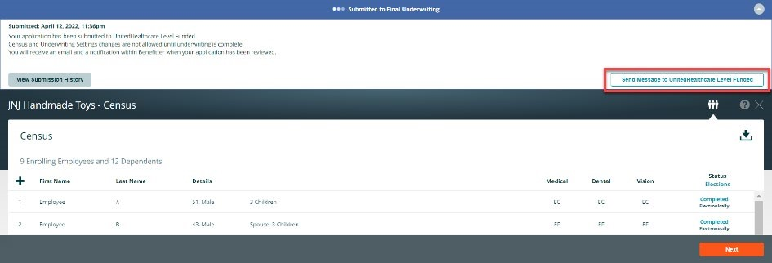 | Persistent Header- Submitted to Final  Underwriting  - Messages at the top of the page will alert you of where you are in the underwriting process, and what steps to take next  - You can enter a note in the message box to communicate with the UnitedHealthcare Level Funded Team, regarding policies and procedures  - At this stage, census and underwriting settings changes are not allowed until underwriting is complete  - You will receive an email and a notification within Benefitter when your application has been reviewed
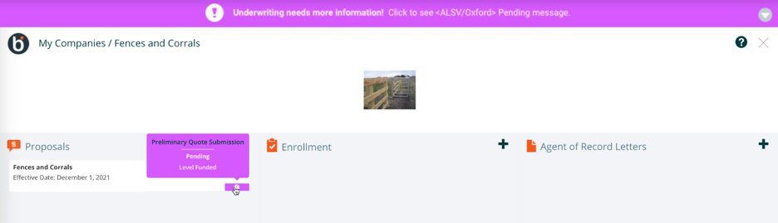 | Resolve Underwriting Questions  - As with the preliminary underwriting request, the UHC Level Funded underwriting team may identify issues that need resolving before they can provide final rates. In this case, you will receive an email alerting you that the final quote submission requires your attention. You will also see a pending status indicator on the client’s homepage  - A message on the Enrollment Checklist page will provide information about the issues that need to be addressed. Once you have entered the required information, click Resubmit for Final Quote Application to have the underwriting team review the updated information
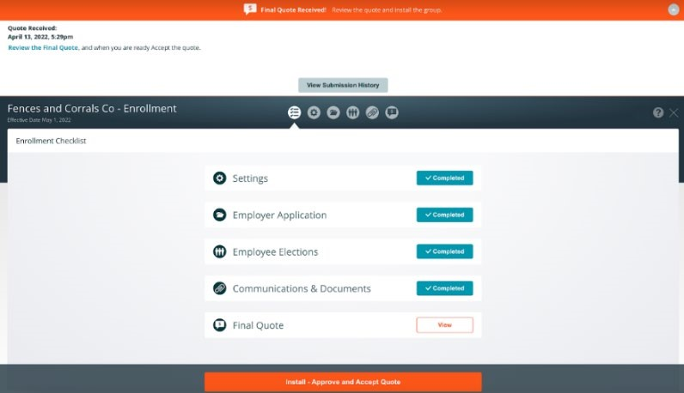 | Receive and Approve Final Underwritten  Rates  You will receive an email when final rates are available. To review the rates:  - Click on the final underwriting email, link in the link email notification  - Or access the company and click on the enrollment  - Review the final quote by clicking on View on the Final Quote checklist or click on the quote icon  - The quotes page displays a comparison between the preliminary and final underwritten rates  - Click on the download icon to save a copy of the preliminary and final quotes  - To accept the final quote and install the group, click Install - Approve & Accept Quote
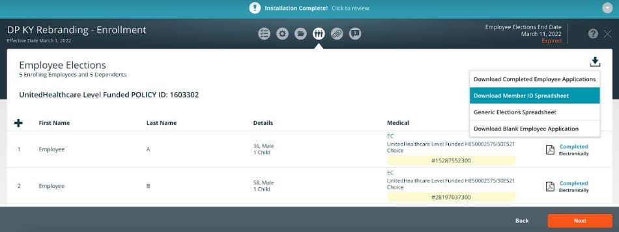 | Confirmation of Successful Installation  - You will receive an email when the group has been installed  - From this point forward, you can review any part of the enrollment but can no longer make changes to it in Benefitter  - The group will now appear in myAllSavers.com and SAMx where you can submit any needed adjustments  - The Member IDs will be added to the employee elections page  - You can download Member ID spreadsheet

proposal election scenario plans are
zz
nnnnjjj

bbbbbbbbb
