Let’s jump-start your knowledge by walking you through the steps to create a company, upload employees to the online census, and create a proposal.

Quick Start Proposal

**Log in**

●

On your Chrome, Firefox, or Edge browser window enter

ei.benefitter.com the system will prompt you to login with

OneHealthcareID

**Create a Company**

●

On the agent homepage, click on the + icon

●

On the Company Information page, enter the company’s state, zip

code, and SIC code

●

Press Next

**Agent Home Page Overview**

Use the following methods to search for a company:

●

Filter company tiles by status (all, active, prospect, test)

●

Sort company tiles

-

●

Search by company name

●

Click on the spyglass icon

●

Access profile by clicking on your name

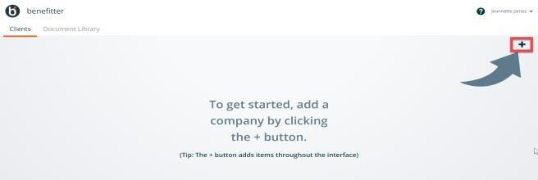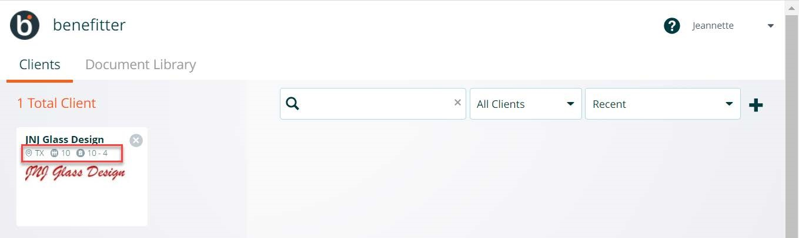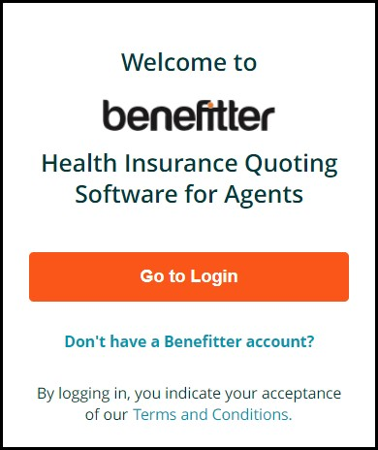

**Add Profile Picture, Agency Logo**

●

Open your profile from the agent homepage

●

Upload a profile picture and agency logo

●

Ensure your other information

Information is correct

**Company Homepage Overview**

●

Access Company Information and Census from the footer

●

Create proposals, enrollments, and Agent of Record letters from

the center section

**Update Company Information**

●

Navigate into the company and click Company Information at the

bottom left of the company homepage

●

Complete Company Information and Contact section

●

Upload the company’s logo

●

The company logo and contact information appears on the

proposal introduction page, making for a professional

appearance

●

If planning to submit electronically to Humana or

UnitedHealthcare Level Funded, enter the company’s tax ID

●

Press Update

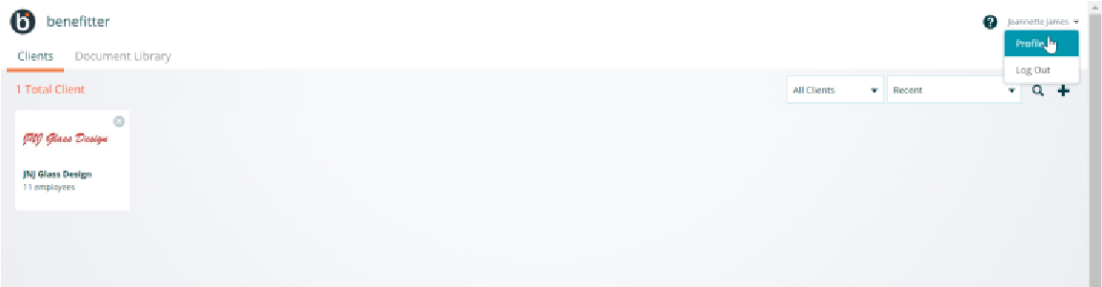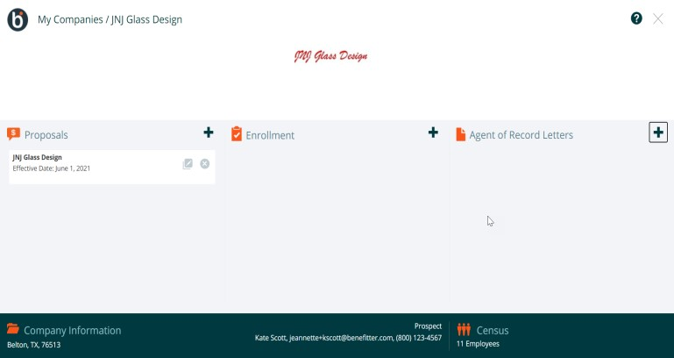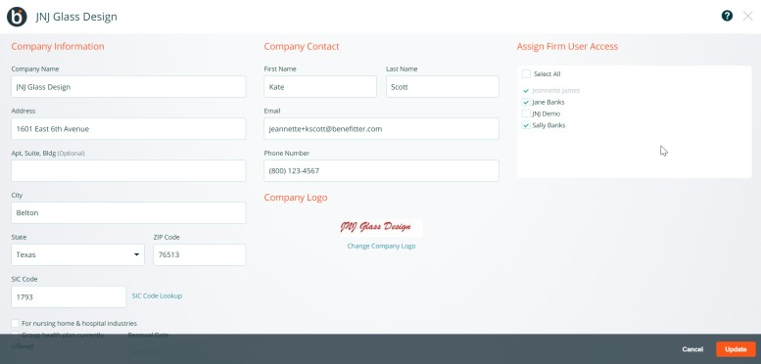

**Census**

**-**

**Upload/Manually Add Employee Data**

After you create the company, press next

●

Choose whether to enter employees via bulk upload o rone

-

Or manually censuspreadsheet

●

When all employees have been added, click Next to exit the

census page

**Census**

**-**

**After uploading employee data**

To access the census, click Census in the bottom right of the company

homepage

●

Add employees (manual or spreadsheet upload)

**+**

icon

●

Delete employees by clicking the X icon

employee’s record

●

Click on the employee’s name to update their eligibility,

enrollment tiers, and demographic information

**Create**

**Proposal**

●

Click on the

**+**

icon in the proposal section of the company

homepage

●

Select a presenter and an effective date

●

Press Create

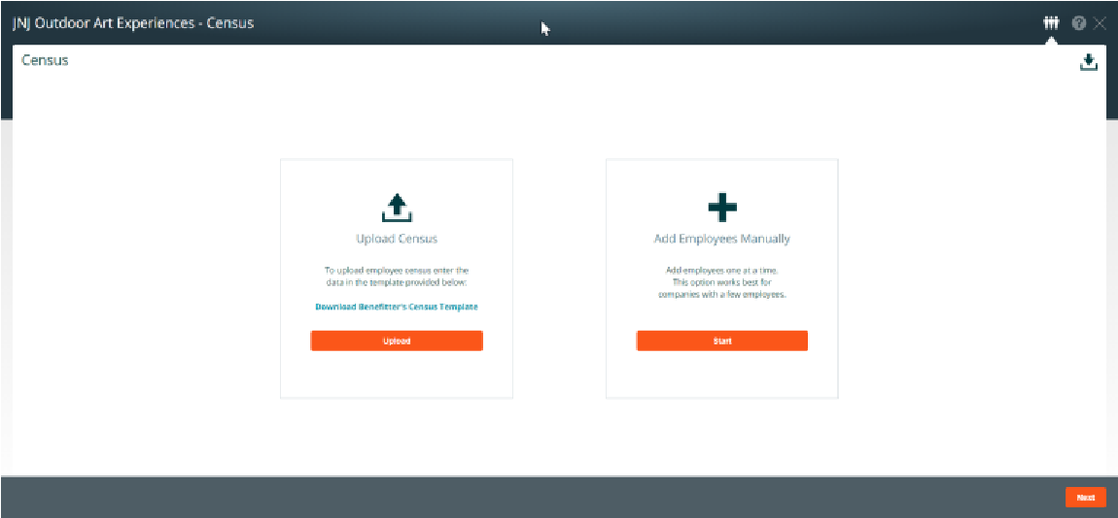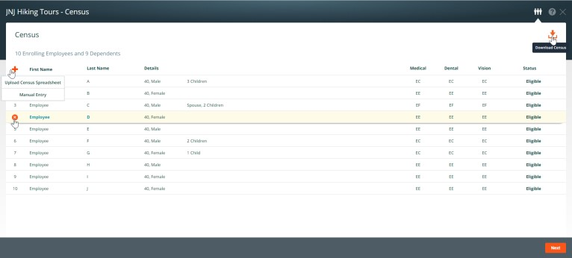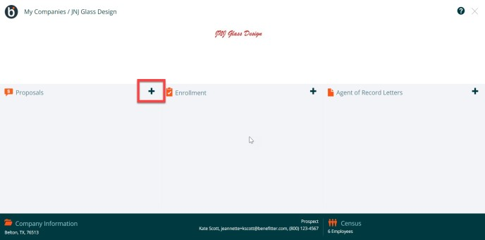

**Proposal Navigation**

**Add Plans to Proposal**

●

Click on the

✚

icon (Medical Plans) located in the upper

navigation

bar

●

Add the plans to the selected plans screen by clicking on the

plan’s

**+**

icon on the far right

●

Click on Selected Plans to look at the plans on the side-by-side

view

●

**See the knowledge note in the appendix section below to**

**learn about the Proposal Elections Scenarios**

**Download Proposal**

●

Click on the download icon

●

Select the PDF or CSV format

●

For the PDF format, choose the employee cost details, appendix

comparison table, and payroll frequency

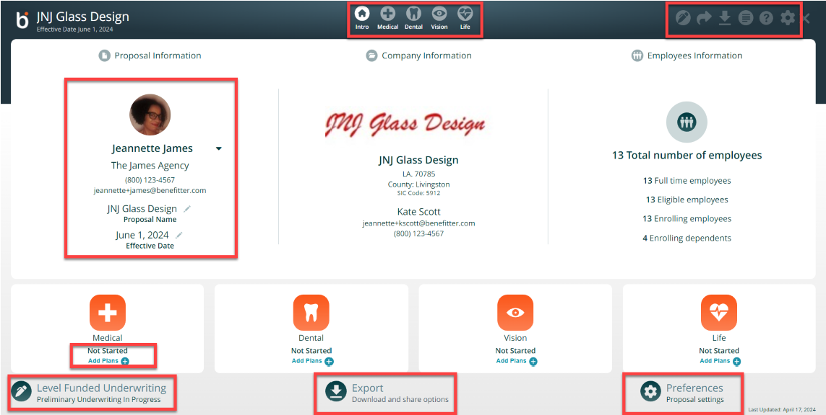

Access the sections of the proposal via the icons in the upper

center of

the page

:

Intro, Medical, Dental, Vision, Basic Life

○

Access the preliminary underwriting request screens

○

Send a link to the proposal (Share Proposal icon)

○

Download the proposal in PDF or CSV format (available

once

you add plans to the proposal)

○

Adjust proposal settin

gs

○

On the proposal area you can select a different presenting agent

○

Click on the pencil icon to modify the proposal name and effective date

○

Add plans to the proposal by clicking on link for Medical, Dental, Vision

or life

○

Access the preliminary underwriting, Export the proposal, or modify

the proposal settings

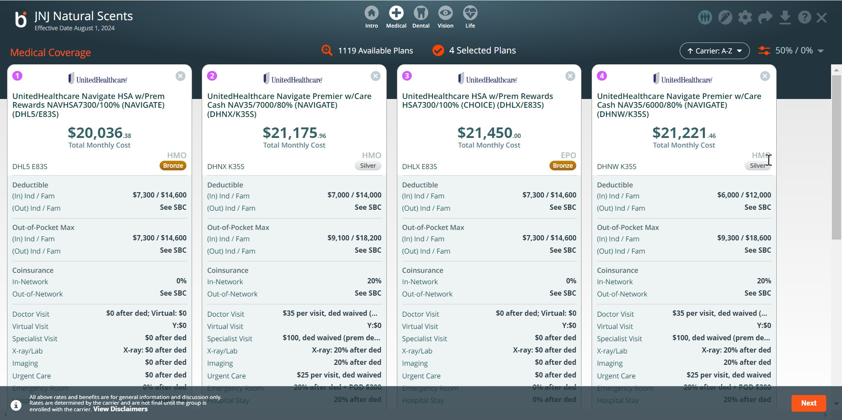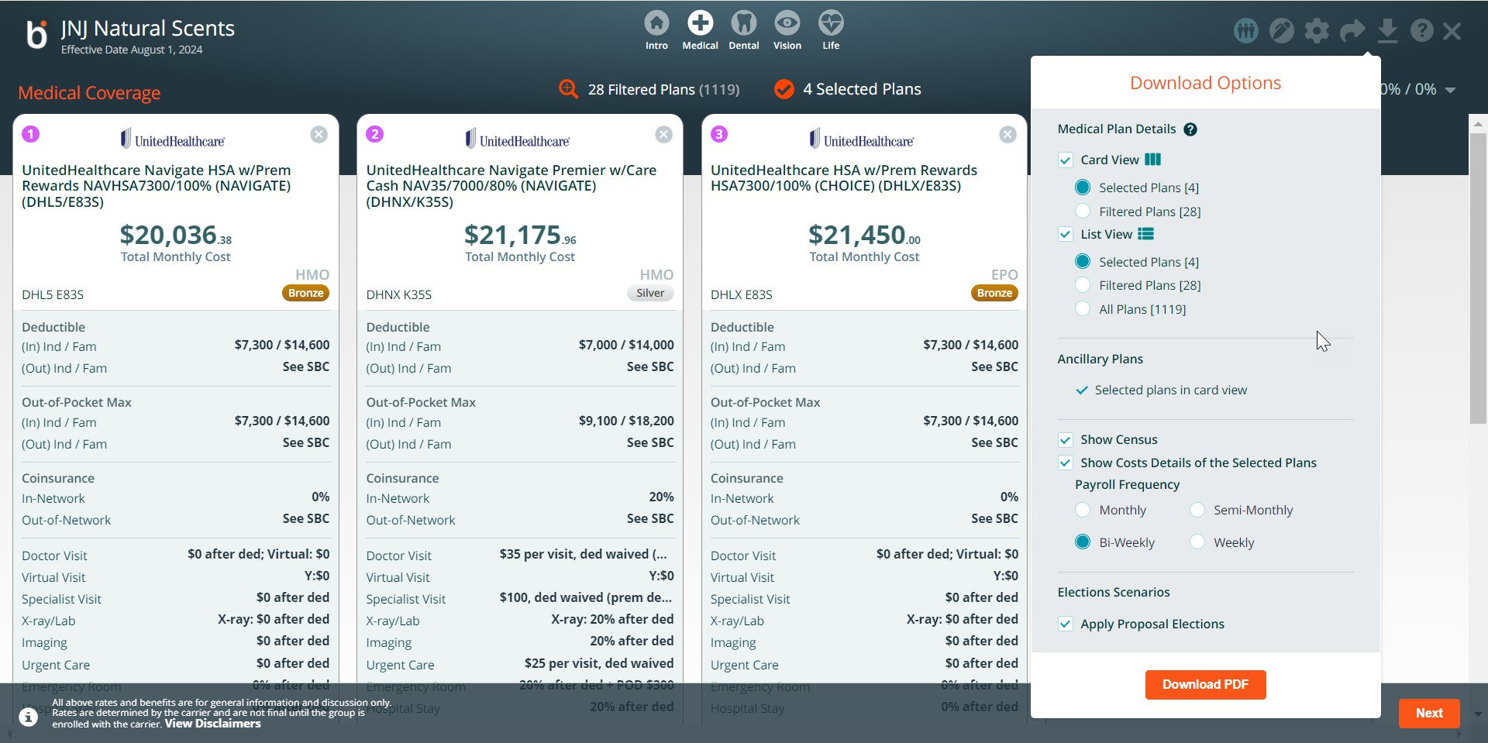

# Preliminary Underwriting Request

Benefitter can be used for the complete underwriting and installation process with United Healthcare Level Funded for small groups (<50 employees). There are 2 ways to obtain a preliminary underwritten quote from UnitedHealthcare Level Funded: individual medical questionnaires (IMQ) or Census path. Based on the number of full-time employees in the census, Benefitter will choose the appropriate path for the group.

**Create Underwriting Request**

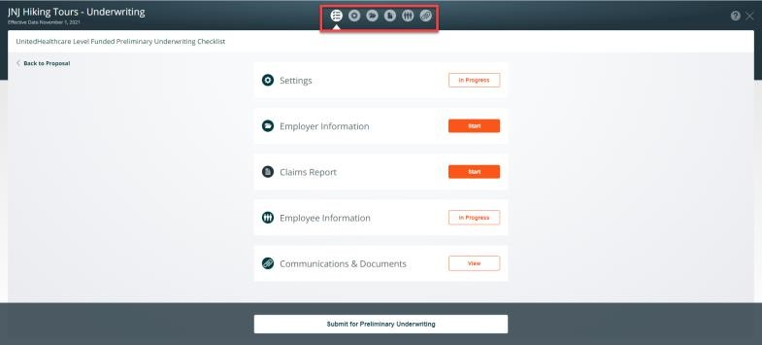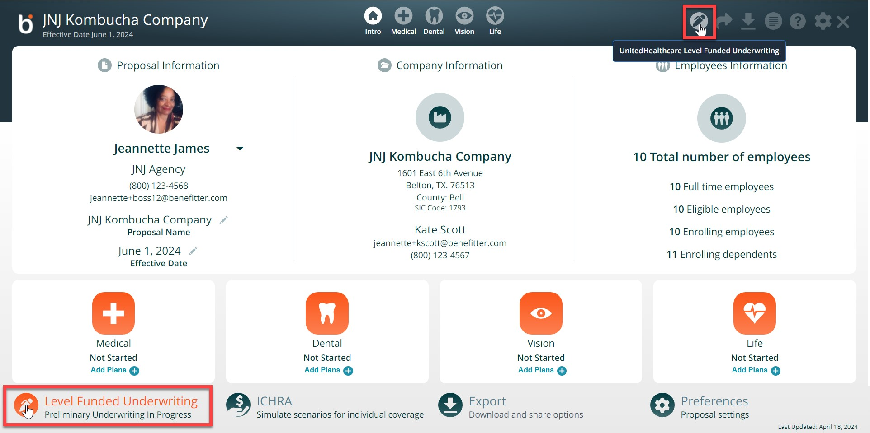

* To access the preliminary underwriting screens:
* Click on the pen icon in the upper right of a proposal
* Or click on the Level Funded Underwriting icon located at bottom left side of the introduction page

## Preliminary Underwriting Checklist - Overview

* Enter the information on the checklist items (settings, employer information, claims report (HB2015 groups), employee information, and communication & document sections).
* After completing checklist items, you will be able to submit the preliminary request.

**Preliminary Request - Settings**

* Click on the settings icon, to change the default proposal settings below
* Underwriting Effective Date, Group Email Distribution List,
* Fee Agreement (PEPM)
* Coordination of Benefits
* Medical Tracking Year
* Rate Guarantee
* Stop Loss Limit, Press the save & continue button

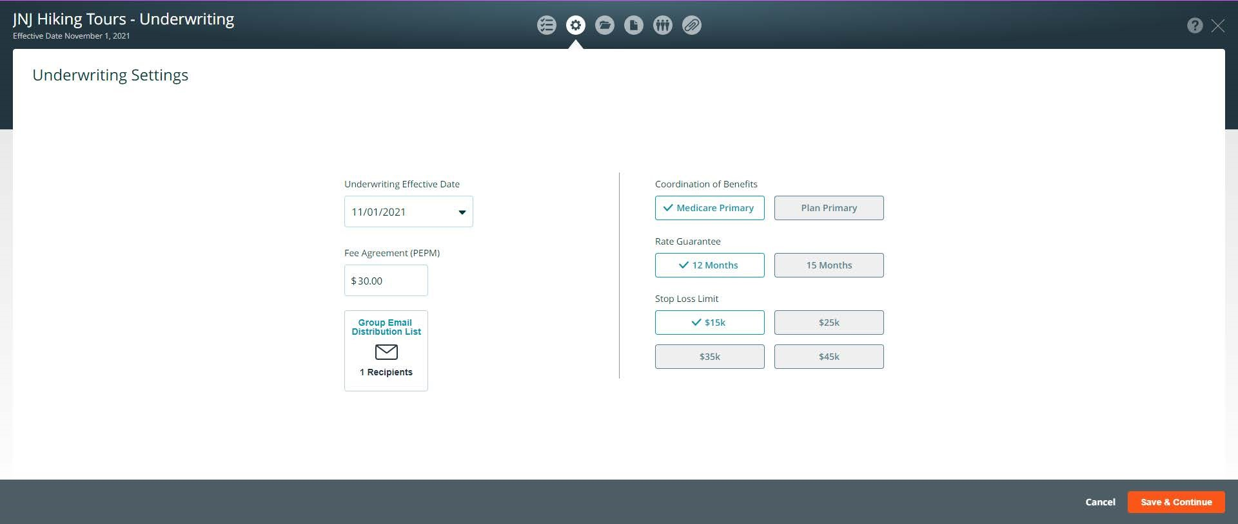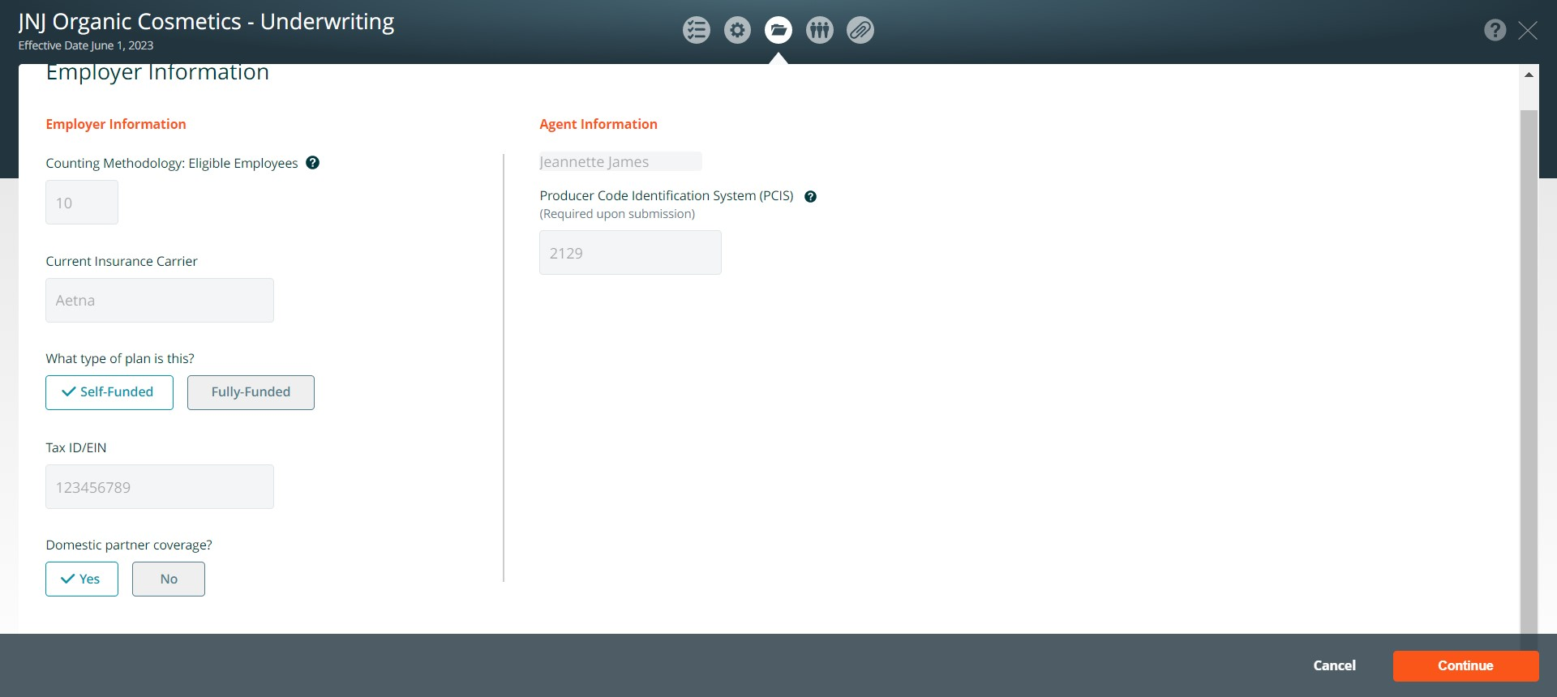

Enter the following information:

* Full Time Employees (FTE)
* Current Insurance Carrier
* Specify whether the current plan is self-funded or fully funded
* Tax ID/EIN
* Choose Yes or No to answer to Domestic Partner
* Designated Agent (you can choose a different agent from the list)

Agent National Producer Code (PCIS id) if you do not know your pcis id, contact your Account Executive

Press the save & continue button

## Texas House Bill 2015: Claims Reports

In Texas only, Benefitter enables groups to submit prior claims reports to replace or supplement IMQ/Census underwriting. This claims report step comes between Employer Information and Census/IMQ. You can always choose to skip claims reports and proceed directly to IMQs. If you select NO for the claims report, choose a reason from the list of values.

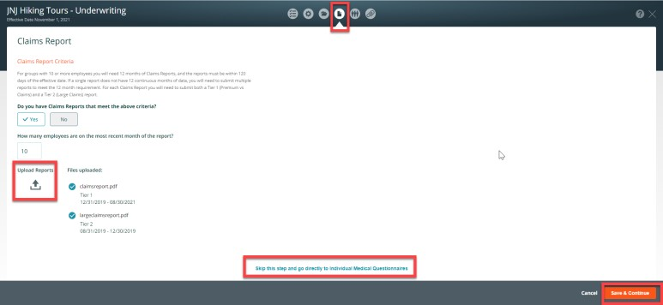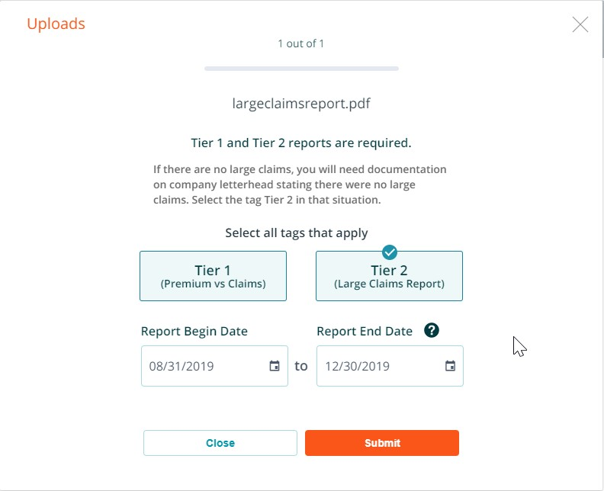

**Benefitter verifies that your claims reports cover the required criteria:**

* 12 consecutive months that conclude within 120 days of the requested effective date. Both Tier 1 (Premium vs Claims) and Tier

2 (Large Claims)

* If a single document does not meet these criteria, you can upload multiple reports.

You will be asked to verify which people on the company census are not

included in the most recent claims report. Benefitter will then determine

whether some o

r all employees will need to fill out individual medical

questionnaires.

**Census Underwriting Path**

For groups who qualify for underwriting via census, only a member

-

Level census is needed for underwriting. The following fields are required for all

enrolling employees and dependents:

●

First Name

●

Last Name

●

Gender

●

Enrollment Tier

●

Date of Birth

●

H

ome Zip

To add another employee to the census, click on the + icon.

Once you have entered all required information, press save and continue.

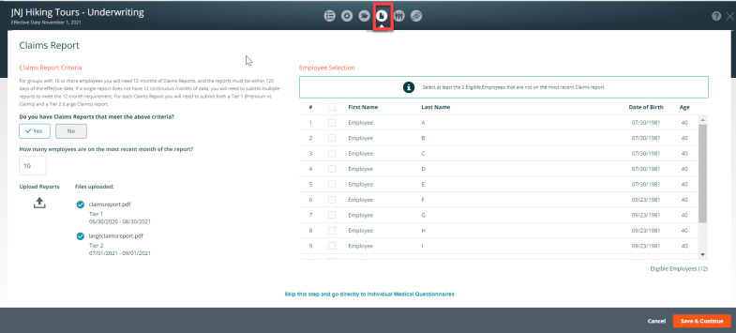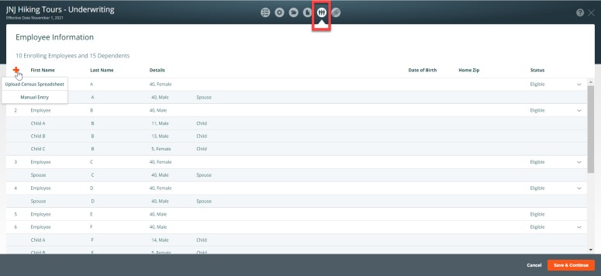

## IMQ Underwriting Path

A medical questionnaire needs to be completed by each employee in the census before the request can be submitted for underwriting. The IMQ process and mobile-optimized employee experience closely mirror those of Benefitter’s employee elections. There are 5 ways to assist employees in completing the questionnaire:

## ● Email Employees

○ Send employees an invite to complete a mobile-friendly medical questionnaire. On the employee notification page, check the names of employees that you are inviting to complete their Questionnaires electronically.

## ● Upload Applications

○ Upload already completed Applications. Click on the download icon to download a blank IMQ. After the employees provide the completed, signed and dated IMQ. Click on the upload application button, on the Employee Questionnaire Upload page check the names of employees on the document you are uploading.

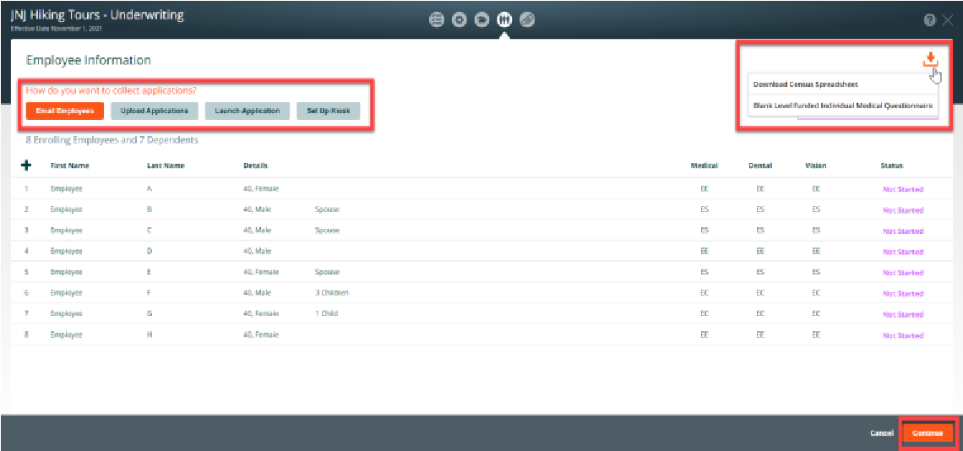

## ● Launch Application

○ Click on the Launch Employee Questionnaire page, on the Launch Employee Questionnaire page select, access an employee’s questionnaire directly to walk them through completing it, or to complete the enrollment.

## ● Set Up Kiosk

○ Set up a computer station for employees and provide access codes so they can complete their questionnaires.

● **Select plans/enroll group on the enrollment page**.

## Communications & Documents

You can send a message to the UnitedHealthcare Level Funded

Team, Attach and download documents, Review last submission messages, Review the submission history

## Submit Preliminary Request

Click on the home icon, click on the Submit for Preliminary Underwriting button Persistent Header-Preliminary Underwriting Request Submitted

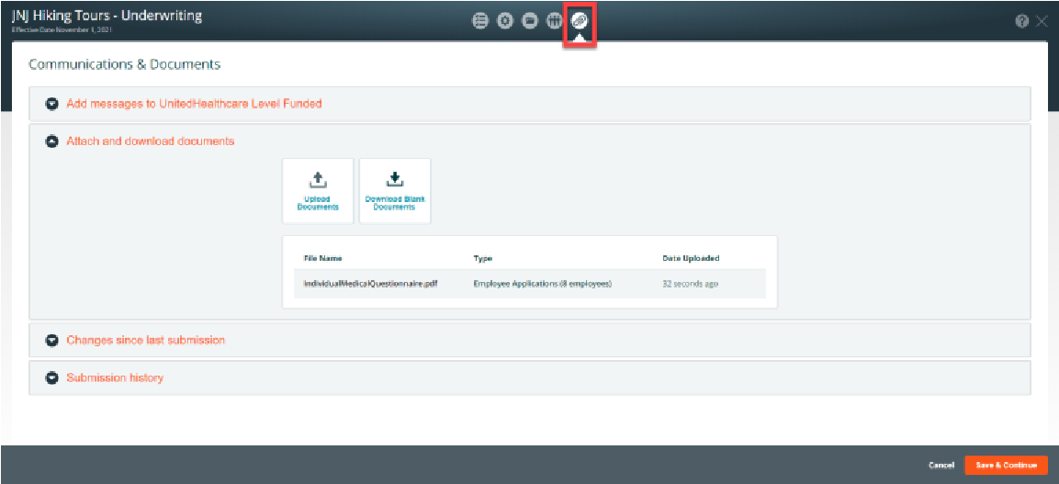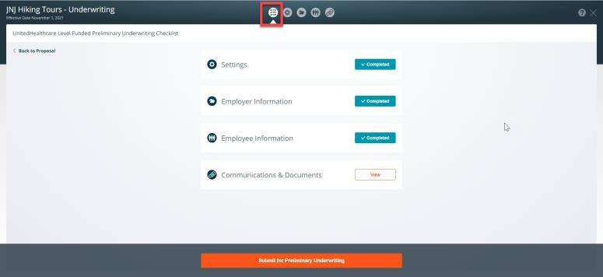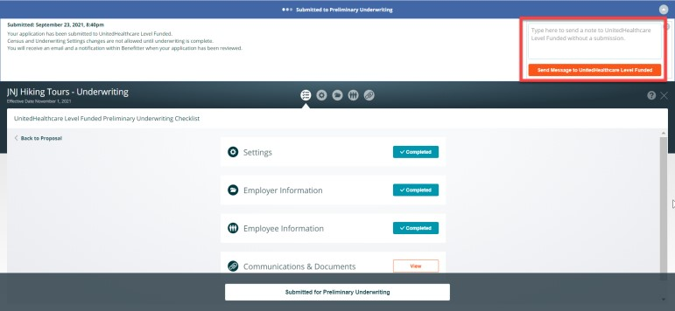

* Messages at the top of the page will alert you of where you are in the underwriting process, and what steps to take next
* You can enter a note in the message box to communicate with the UnitedHealthcare Level Funded Team
* At this stage, census and underwriting settings changes are not allowed until underwriting is complete.
* You will receive an email and a notification within Benefitter when your application has been reviewed

## Submitted Underwriting Request

Once you have submitted your request for preliminary underwriting, its status will be displayed on the related proposal title on the client’s homepage. Resolve Underwriting Questions - Pend

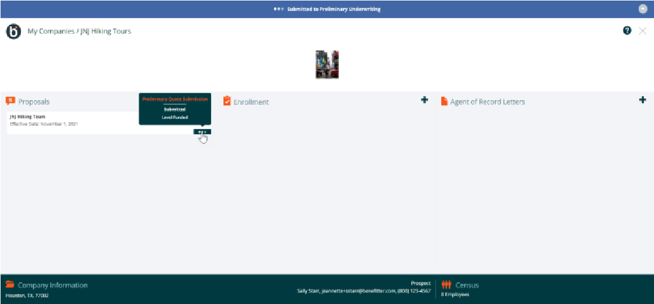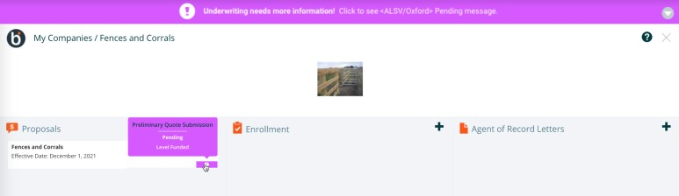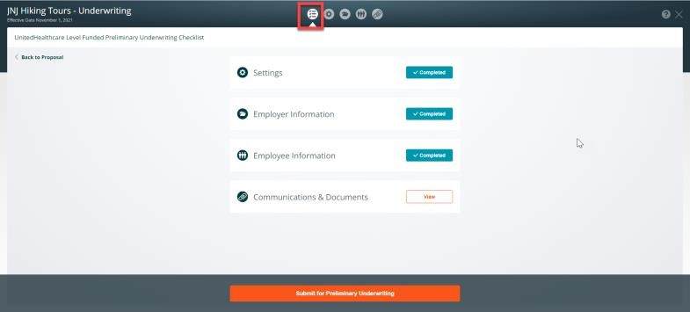

After your request has been reviewed by the underwriting team, you might receive an email notification requesting that you review and resolve issues. Click on the link in the email message body to log into Benefitter; this will direct you to the company homepage. Make the required modifications and resubmit the request to underwriting.

**Receive Underwritten Rates**

Once underwriting has reviewed and approved your proposal, you will

receive an email notification informing you that preliminary underwriting

has been completed.

●

Click on the link in the email

●

The system will direct you to the Company home page

**Finalize Proposal**

Before creating an enrollment, make sure that any plans (medical, dental,

vision, or life) that the employer would like to offer are selected in the

proposal.

**Refer to the Quick Start**

**Enrollment Guide for instructions on how**

**to elect, enroll and install the**

**group.**

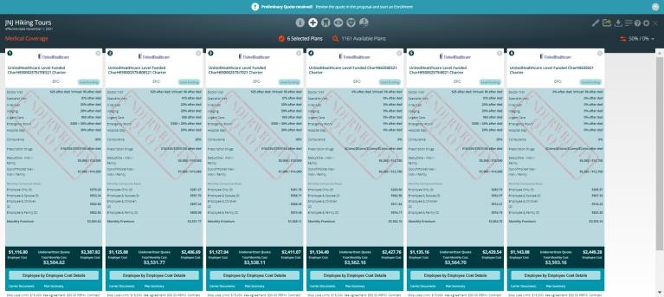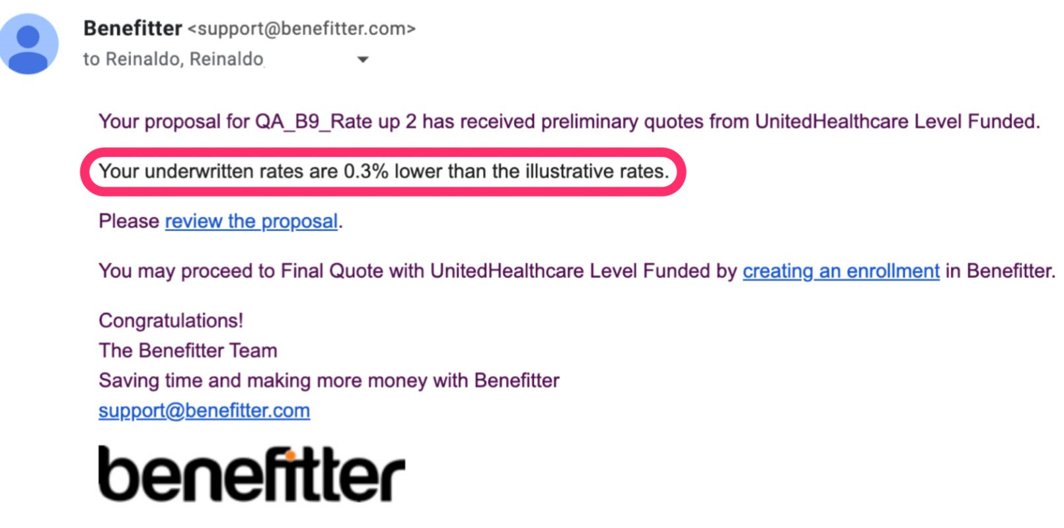

**Appendix:**

**Proposal Elections**

You will have the ability to make plan elections at the Proposal step in Benefitter, to provide a more accurate quotes based on the plan elections you expect employees to make. The plan elections will update the quote in the Benefitter application, as well as in the PDF and spreadsheet outputs. Click on the spreadsheet link to download the Employee Election Spreadsheet. By default, all proposal selected plan costs are calculated considering **all eligible** employees. **You must add all employees to plans on the proposal elections scenario screen to get the most accurate price estimates**. When applying the proposal elections, you can have a more realistic cost estimates by considering only the employees expected to choose each plan. To add a life plan to the proposal election scenario, click on the down icon located at the bottom left corner of the proposal screen.

Click on the spreadsheet link to download the Employee Election Spreadsheet. Click Back to go back to proposal coverage tier. Or click Next to go to the proposal introduction page.

**Apply Proposed Elections**

Click on the rate type, employer contribution widget, click on the Apply Elections toggle to the left to apply the proposed elections to the plans on the proposal. The plan elections will update the quote in the Benefitter application, as well as in the PDF and spreadsheet outputs.

The proposal election scenario plans are added to the plans on the side by side.

Employee cost details employee election scenario will be applied to the plans

Proposal pdf download options - If you enable the elections scenario option on the employer contribution screen, you can choose the elections scenarios details as one of the download options.

**The proposal pdf has a new look and feel.**

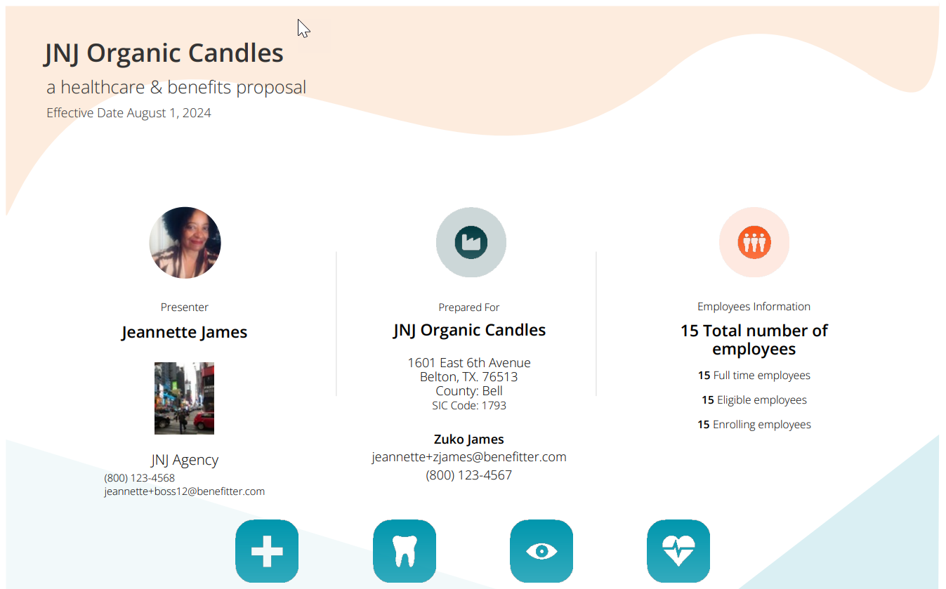

**Proposal elections**

