**Employee Navigator export FAQs**

**What is the Employee Navigator export?**

Gives Brokers the ability to electronically export sold case information from Benefitter to Employee Navigator (EN) to assist in automatically configuring a group in EN. The export includes census data, plans, rates, contributions, and benefit summary details.

This process will also help support cases that want to have employee elections completed in EN.

**What products are supported?**

Medical (fully insured and level funded)

Dental

Vison

Life (Basic Life)

**Before you begin, users must have**

1. Employee Navigator license and active logon credentials
2. Activated Benefitter account

**What data is exported to Employee Navigator?**

1. Group name
2. Census (*)
3. Plans
4. Rates
5. Employer Contributions (percentage or monthly defined amount)
6. Plan summary data (plan card)
7. Link to Summary Benefits and Coverage

**\*Can I re-export census data?**

No. Census data is only imported once during the initial export and can only be imported if the Group does not have census data in Employee Navigator. Once a case is exported from Benefitter to EN any further census updates would have be made in EN.

**How do I export to Employee Navigator?**

When you have a “sold” case situation:

1. In Benefitter
   1. Review the case information, census and intended plans to ensure everything is correct
   2. Start an Enrollment by clicking the “ + “ on the Proposal page
   3. Navigate to the Employee Elections page.
   4. Select the ‘Export to Employee Navigator’ arrow icon (upper right margin).
   5. Enter Employee Navigator credentials.
2. In EN
   1. On the EENav home page, go to Pending Integrations.
   2. Select the Group and follow the prompts to complete the group integration.

**Does my Group need to be in Employee Navigator before I export?**

No, users have the option to create a new group or link to an existing group.

**My Group is already in Employee Navigator, can I still export?**

Yes, users can export a case and link it to an existing group in EENav. Census data will be imported but only if the Group does not have census data in EENav.

**Need to make plan changes?**

1. In EENav, select Benefits and the plan to delete.
2. Next select the edit button and then trash icon (bottom margin) to delete the plan.
3. Return to Benefitter and delete the Enrollment.
4. In Benefitter
   1. Edit the Proposal with the desired plans.
   2. Create a new Enrollment.
   3. On the Employee Elections page, select the Export to Employee Navigator arrow icon.
5. Return to EENav home page
   1. select Plan Notifications.
   2. Select the company’s link from the list.
   3. Locate the plan in the list and select Add.

**Can I import employee elections from Employee Navigator to Benefitter?**

Yes. Employee Navigator elections can be downloaded to a spreadsheet from the reports page. and you can then return to Benefitter’s Employee Elections page to upload.

**How to download employee elections to a spreadsheet from Employee Navigator**

1. In EN
   1. Important! Confirm all dependents have SSNs in EENav.
   2. Go to Reports.
   3. Go to Ad Hoc Reports and select Column-Based Report.
   4. Select the following report parameters.
   5. Select Save and then name the report.
   6. Select View.
   7. Select Download.
   8. Locate the spreadsheet in your Downloads folder (named ‘AdHocReport’).
   9. Important! Remember to save this report as a Favorite for future cases.

|  |  |  |
| --- | --- | --- |
| **Employee fields** | **Enrollment fields** | **Options** |
| Social Security Number | Medical Plan | Include dependents |
| First Name | Medial Plan coverage |  |
| Last Name | Medical Decline Reason |  |
| Sex | Dental Plan |  |
| DOB | Dental Plan coverage |  |
| Sex | Vision Plan |  |
| Hired On | Vision Plan coverage |  |
| Address 1 | Group Life Plan |  |
| City |  |  |
| State |  |  |
| County |  |  |
| Zip |  |  |
| Phone (Home) |  |  |
| Primary Email |  |  |
| Annual Base Salary |  |  |
| Hours per Week |  |  |
| Enrollment Completed |  |  |

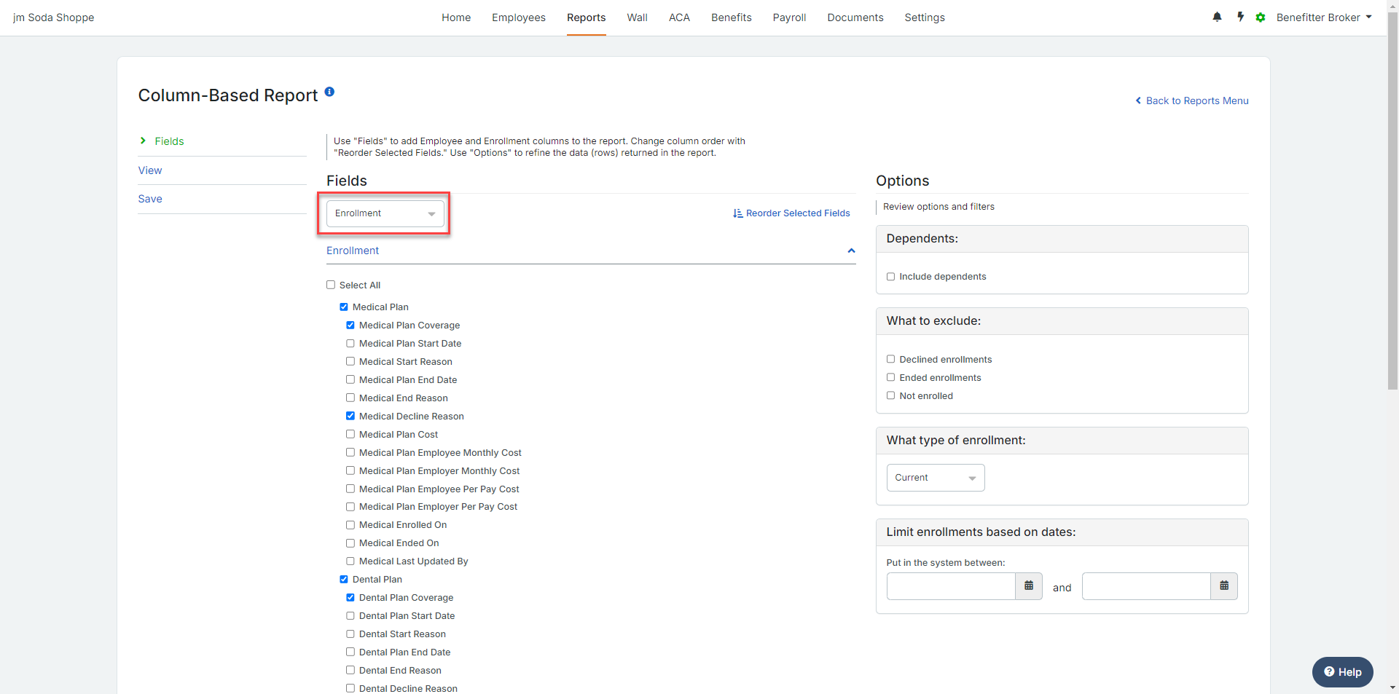

**What happens when elections spreadsheet has:**

An Employee with both an enrolling tier and a waiver reason on the same row? They are loaded as Declined in Benefitter.

**How to upload the elections spreadsheet into Benefitter to support case installation**

1. In Benefitter,
   1. Return to the Employee Elections page.
   2. Select Upload Spreadsheet.
   3. Select Upload Employees Spreadsheet and the ‘AdHocReport’ from your downloads folder.
   4. Select continue to complete the upload.
   5. Complete the other applicable checklist steps for enrollment (e.g., ER app, supporting documents,

**Can I electronically export employee elections from Employee Navigator to Benefitter?**

Not at this time, however, users can download completed elections to a spreadsheet from Employee Navigator’s reports module and then upload it on Benefitter’s Employee Elections page.

**Where can I get Employee Navigator support?**

In Employee Navigator, select the Support link from the top menu, then select the Search knowledge base link to login into the knowledge base to search for help articles or submit a request.