

# What’s New

### PLAN CARD REDESIGN

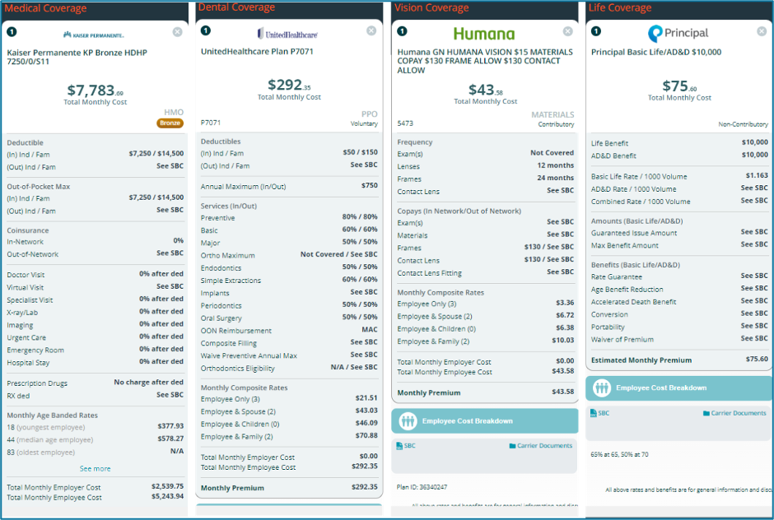

We’ve made our plan cards easier to read, with a new layout that puts the most important information front and center! You’ll now see the total cost at the top, and beneﬁts like Deductible, Out-of-Pocket, and Coinsurance clearly highlighted. For Medical plans, we’ve added Out-of-Network beneﬁts and Virtual Ofﬁce Visits, plus more details for Dental, Vision, and Life plans.

This means faster, clearer comparisons when reviewing plan options.

### PROPOSAL ELECTIONS

Say goodbye to guesswork and hello to more precise quoting.

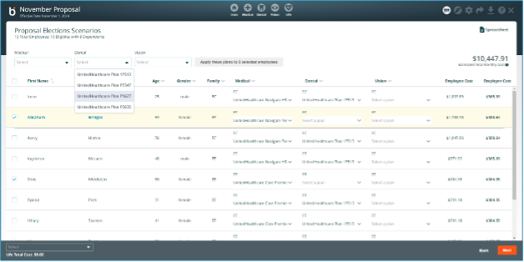

Brokers can now select which plan an employee might select during enrollment right on the proposal, giving clients a more accurate monthly premium before enrollment. These elections will show up in the Employee Details section of your PDF proposals.

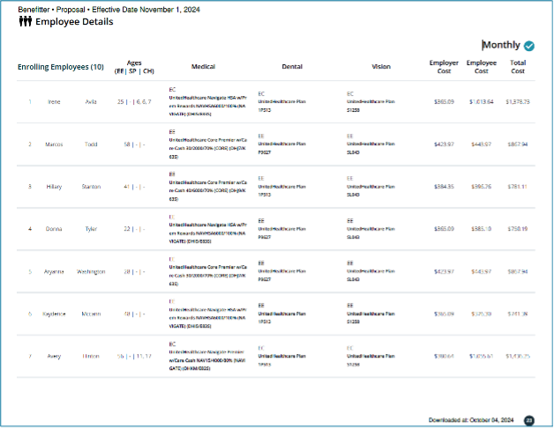

### PDF PROPOSAL OUTPUT

A more professional, organized look that makes reviewing proposals a breeze.

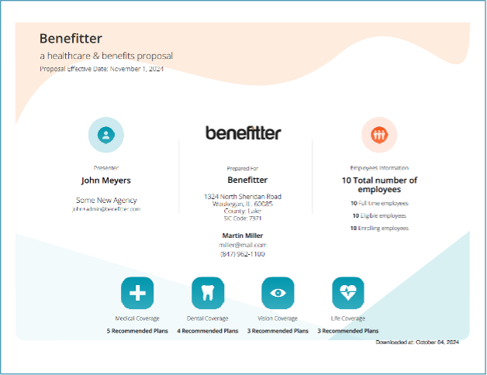

Our proposal PDFs just got a major upgrade! Now featuring a redesigned cover page, a handy table of contents, and detailed census info (including dependents and zip codes). Plus, you’ll see employee plan elections listed for easy reference.

Generate your next proposal to see the difference.

# What’s Coming in October

Save time and reduce errors by automating your data transfer.



Soon, you’ll be able to seamlessly export sold case details (including census data, plans, and rates) directly from Beneﬁtter to Employee Navigator.

Stay tuned, this feature will be live soon!

More choices for your clients to help ﬁll coverage gaps.



We’re excited to introduce Transamerica’s new GAP coverage plans, offering more ﬂexibility and options in states like IA, MO, NE, KS, and FL. These plans include new rider coverage options too.

Keep an eye out for these new options.

We’re thrilled to introduce **two new level-funded medical carriers**, Optimyl and Angle, designed to give you more ﬂexibility in meeting your clients' needs and help streamline your quoting process.



**Optimyl** offers illustrative rates quickly and easily through Beneﬁtter. You can capture employee plan elections using Beneﬁtter’s Enrollment tool, then obtain

underwritten rates and submit cases for installation through the carrier website. Beneﬁtter will not facilitate underwritten rates or installation for **Optimyl plans**.

We're conducting a limited market rollout starting in Texas and Illinois.



With **Angle**, most cases qualify for **census underwritten rates** in just minutes, making it easier than ever to get quotes fast. Angle will integrate with Beneﬁtter’s Enrollment tool to capture employee plan elections. Once complete, you can submit cases directly on Angle’s website for installation.

# Did You Know?

## DID YOU KNOW YOU CAN CHANGE THE PEPM ON THE PROPOSAL?

Tailoring proposals just got a whole lot easier!

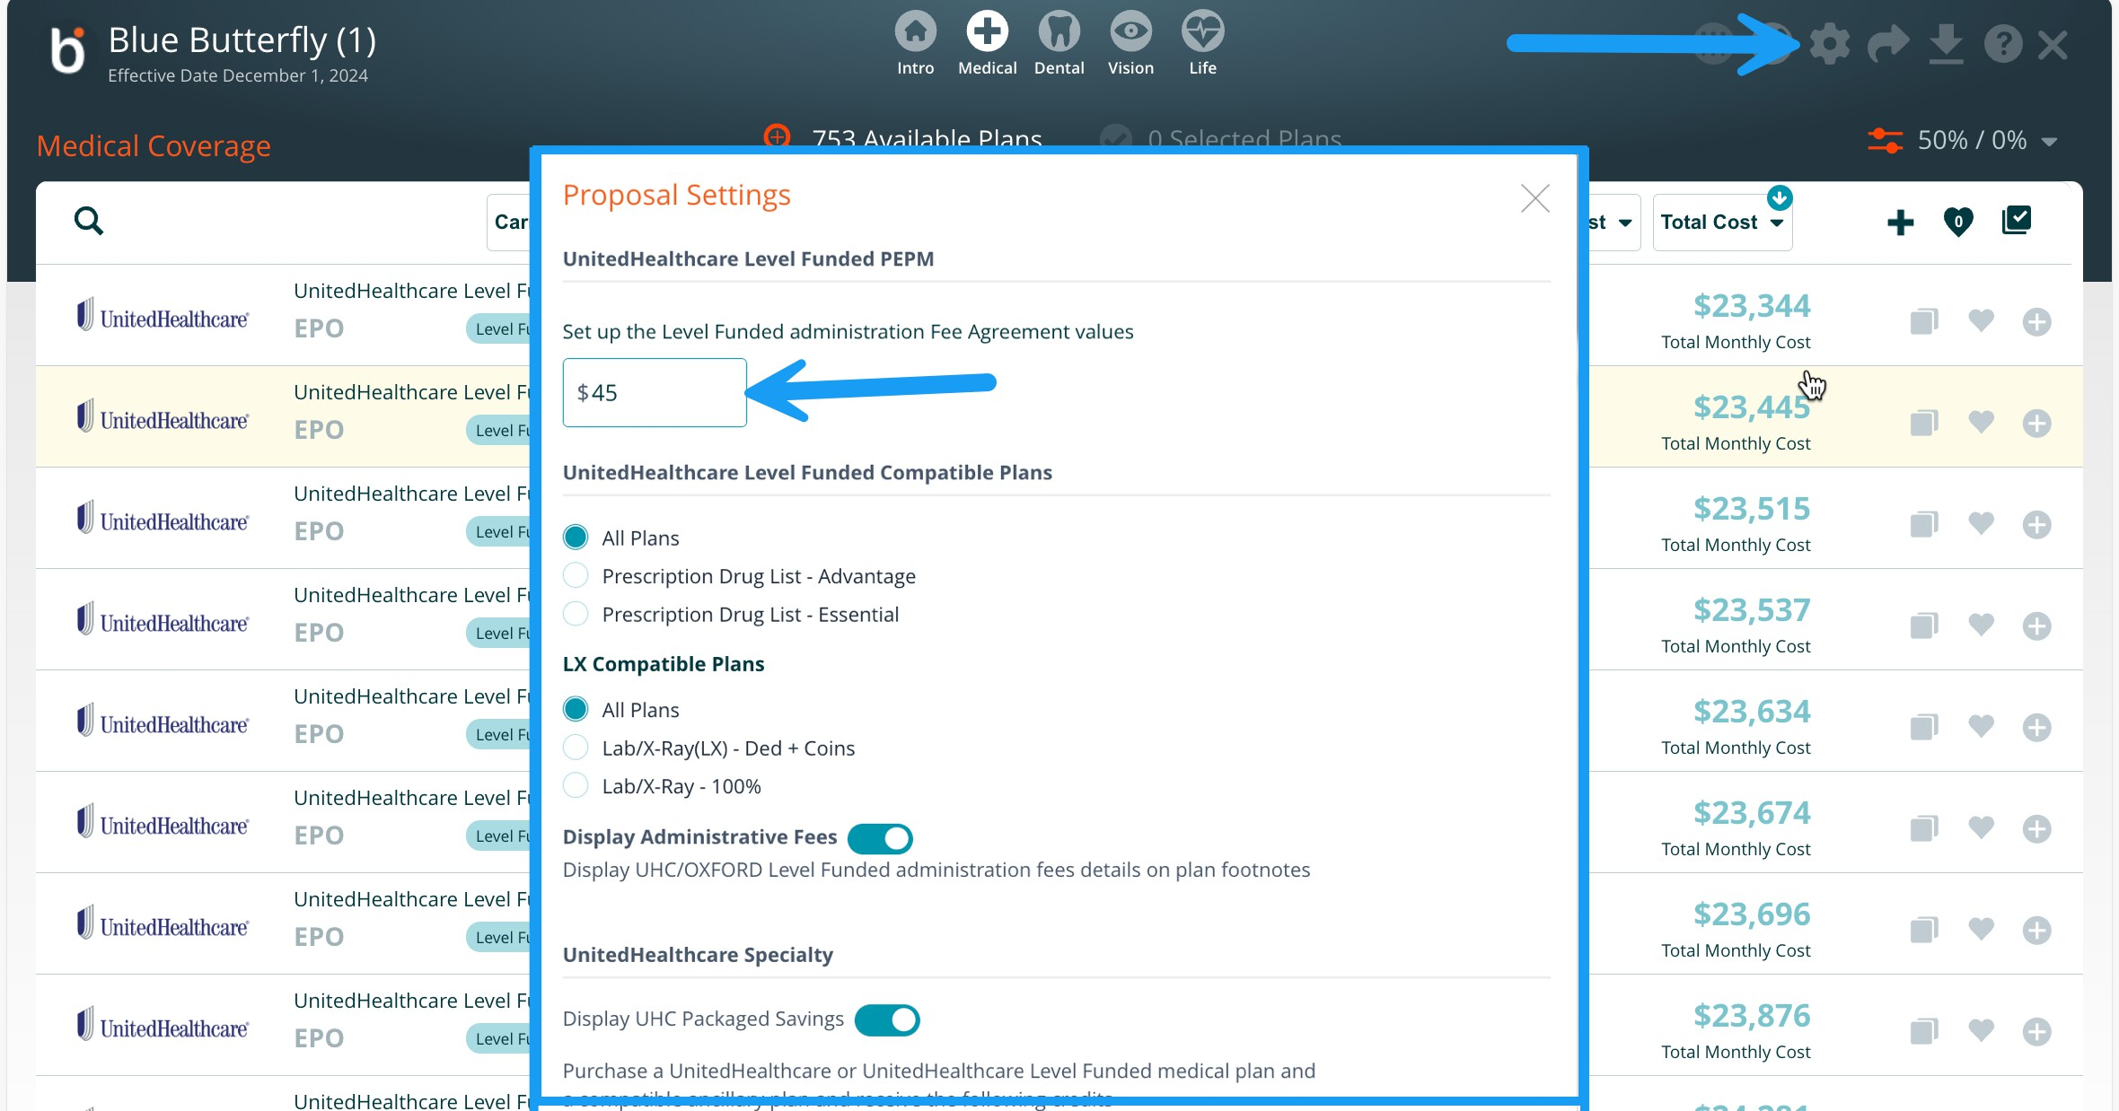

With just a few clicks in your proposal settings, you can easily adjust the PEPM (Per Employee Per Month) to customize your quotes even further.

## DID YOU KNOW YOU CAN FILTER BY COMPATABILITY?

It’s a time-saver that ensures you're presenting the most relevant options.

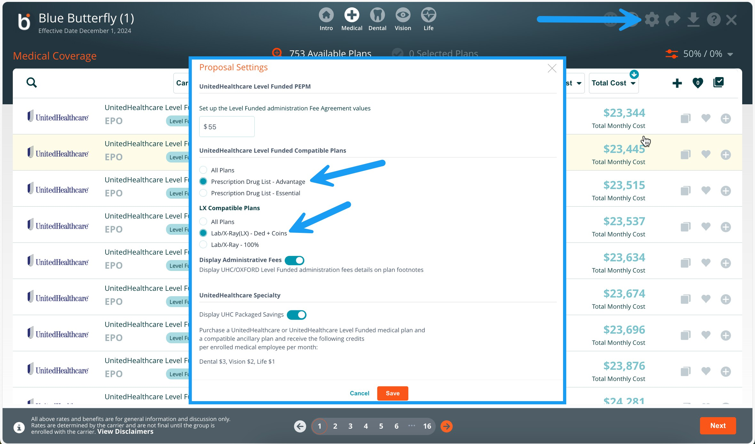

When creating proposals, you can ﬁlter for level-funded compatibility to quickly ﬁnd plans that ﬁt your client’s funding preferences.

#### [Benefitter Help Center](https://help.benefitter.com/)

Access a wide range of resources including detailed step-by-step instruction guides and FAQs to help you make the most of our platform on our Help Center.

#### Need Live Assistance?

Live support is available to assist you Monday-Friday, 8:00 am – 7:00 pm Central Time at (800) 419-0116 or send an email to [support@beneﬁtter.com](mailto:support@benefitter.com).

#### [Submit a Support Ticket](https://help.benefitter.com/contact-us/)

[**Attend Training**](https://help.benefitter.com/training/)

[](http://www.linkedin.com/shareArticle?url=https%3A%2F%2Fmailchi.mp%2Fbenefitter%2Fin-the-loop-with-benefitter-june-2022-edition-6741353&mini=true&title=In%2BThe%2BLoop%2Bwith%2BBenefitter%3A%2BOctober%2B2024%2BEdition)[](https://us13.forward-to-friend.com/forward?u=6988d60436d637c0786424e2d&id=472c1a8426&e=%5BUNIQID%5D)[Share](http://www.linkedin.com/shareArticle?url=https%3A%2F%2Fmailchi.mp%2Fbenefitter%2Fin-the-loop-with-benefitter-june-2022-edition-6741353&mini=true&title=In%2BThe%2BLoop%2Bwith%2BBenefitter%3A%2BOctober%2B2024%2BEdition) [Forward](https://us13.forward-to-friend.com/forward?u=6988d60436d637c0786424e2d&id=472c1a8426&e=%5BUNIQID%5D)

*Copyright © 2022 Beneﬁtter. All rights reserved.*

You are receiving this email because you expressed interest in Beneﬁtter.

Beneﬁtter 9151 Boulevard 26

North Richland, TX 76180

Want to change how you receive these emails?

You can [update your preferences](https://benefitter.us13.list-manage.com/profile?u=6988d60436d637c0786424e2d&id=ecd561b02f&e=%5BUNIQID%5D&c=472c1a8426) or [unsubscribe from this list](https://benefitter.us13.list-manage.com/unsubscribe?u=6988d60436d637c0786424e2d&id=ecd561b02f&t=b&e=%5BUNIQID%5D&c=472c1a8426).