Add TransConnect GAP plan to Proposal

Add a fully insured Medical plan to the proposal, then add GAP coverage by selecting the '+ Add GAP' button.
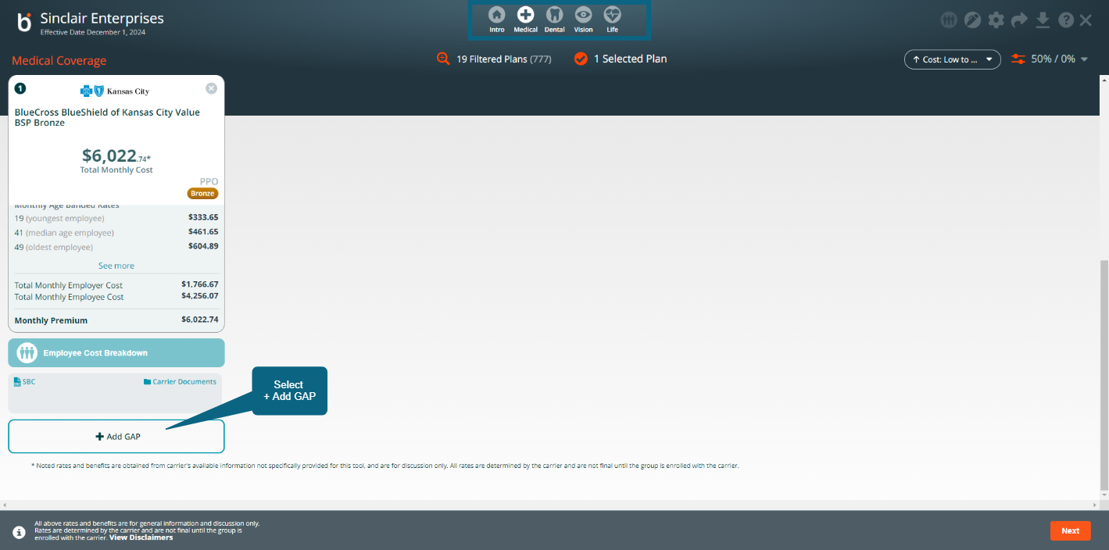

Next, use the slider to select the Inpatient Benefit amount, then select the Plan Option from the pull-down menu.
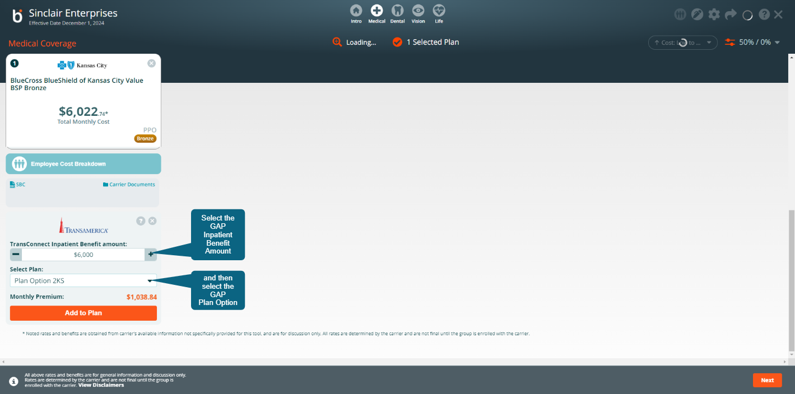

Select the 'Add to Plan' Button to add the GAP plan to the Proposal.
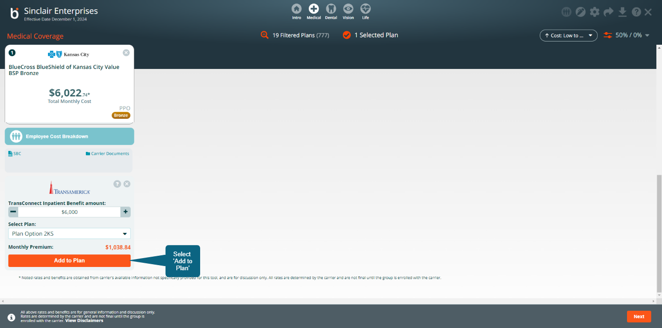

GAP plan has been added to the Proposal and Total Monthly Cost has been updated to reflect the GAP coverage.
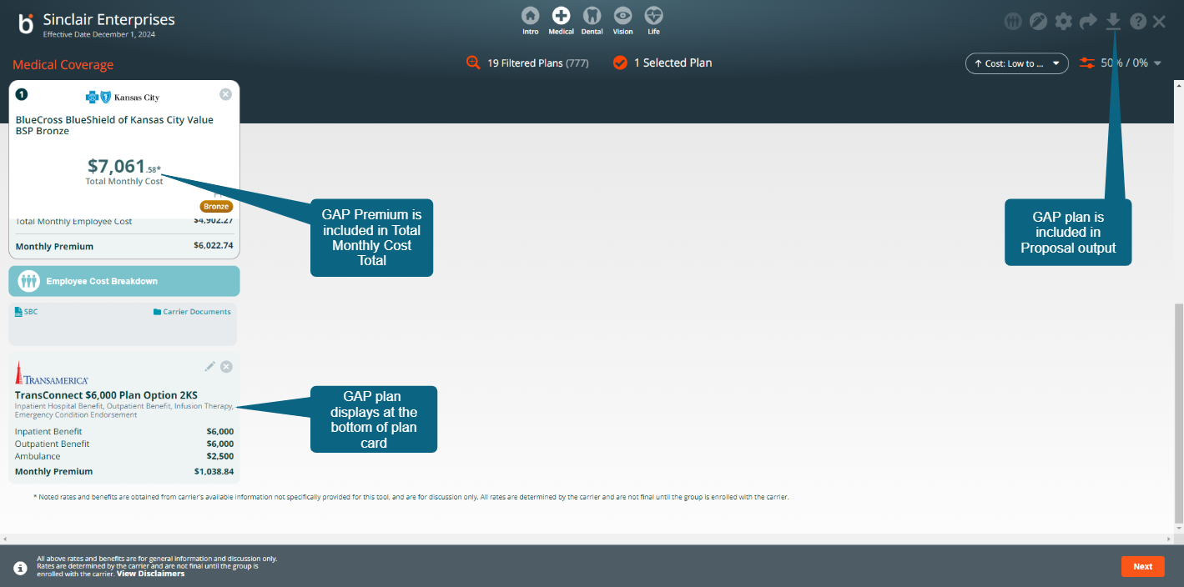

Add the GAP plan to the Enrollment.
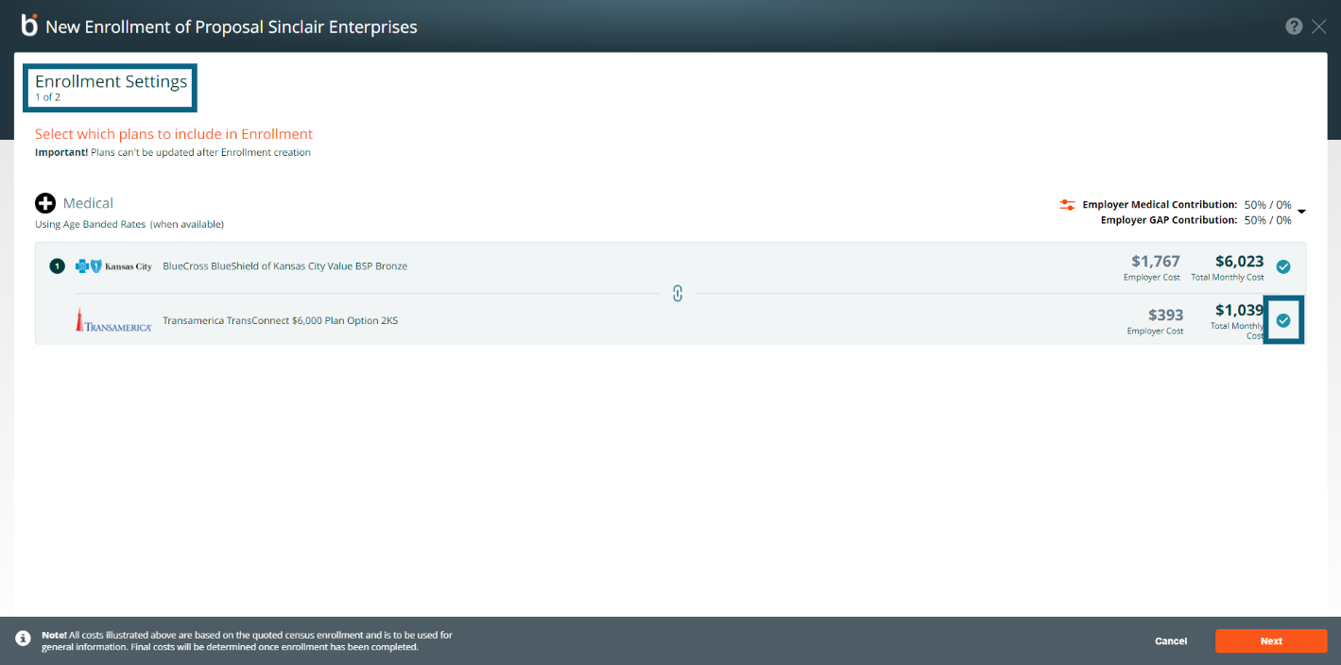

During employee plan elections, the Broker can add the GAP plan on the Employee's behalf.
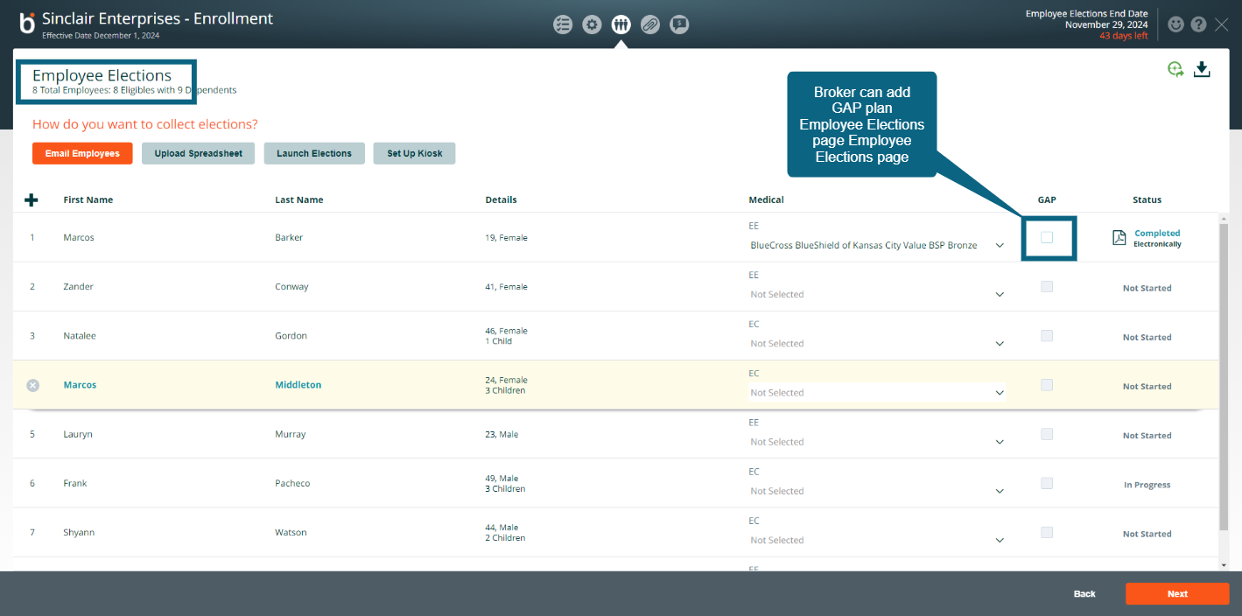

When the employee is choosing plans, GAP is presented as an optional plan election.
