**Add plans to Enrollment – Level Funded & Fully insured plans can be added to the enrollment.**

In this example, underwritten plans were added to the proposal.

Create the enrollment

Add the desired plans to the enrollment, complete the enrollment settings process.

You realize that you forgot to add a plan to the enrollment to add the plan(s) to the enrollment, do the following:

Access the proposal that you selected to create the enrollment

Search for the plan using the search option or filter to find the needed plan. Click on the + icon to add the plan to the selected plans list

Now there are 3 plans on the side by side. After adding the plan(s) to the proposal click on the X to close the proposal.

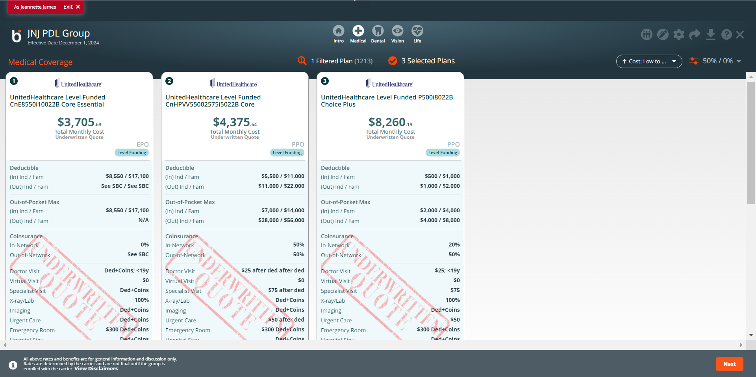

Click on the enrollment

Click on the setting task button

Click on the + icon to add the plan(s) to the enrollment, press next. To go back to the enrollment checklist, click on the icon

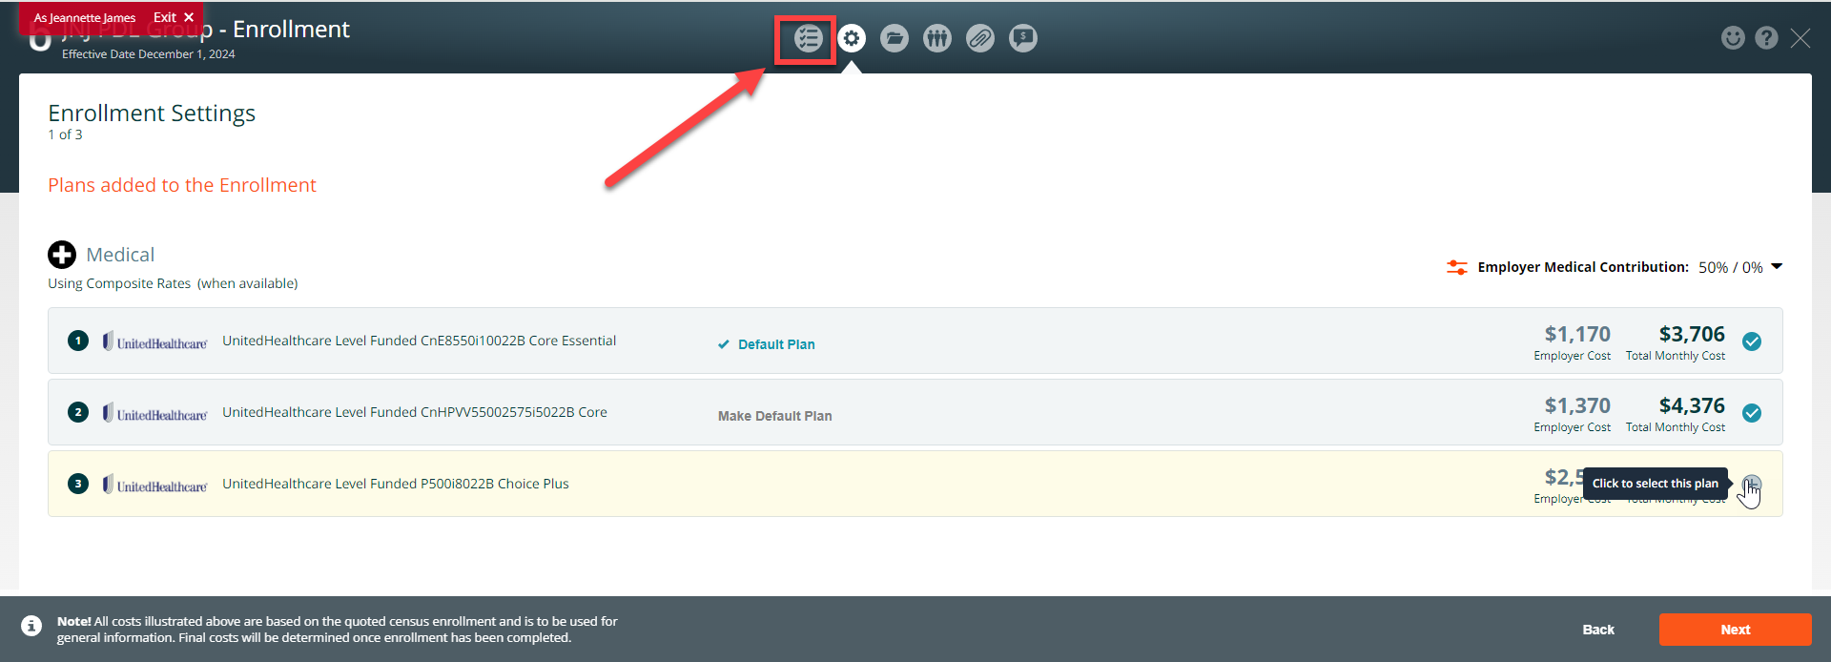

The new plan(s) is now available in the enrollment. Use one of the enrollment options to add the new plan to the election.

