# January 2025 Newsletter

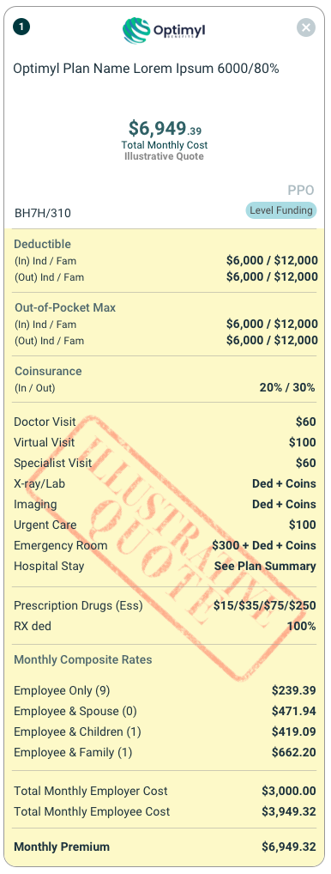

We’re bringing some exciting features that will make your job easier, and your client experience smoother.

# Check out what’s new:

**Introducing a New Level Funded Carrier.**

We’re thrilled to announce that **Optimyl**, our new level funded carrier, is now available for quoting in Illinois and Texas! Please note, Optimyl offers illustrative rates only, so you can get started by creating non- electronic Optimyl enrollments. Once your employee plan elections are captured via Benefitter’s electronic elections tool, simply head over to Optimyl’s website to obtain underwritten rates. It’s that easy!

# Share Proposals with Ease.

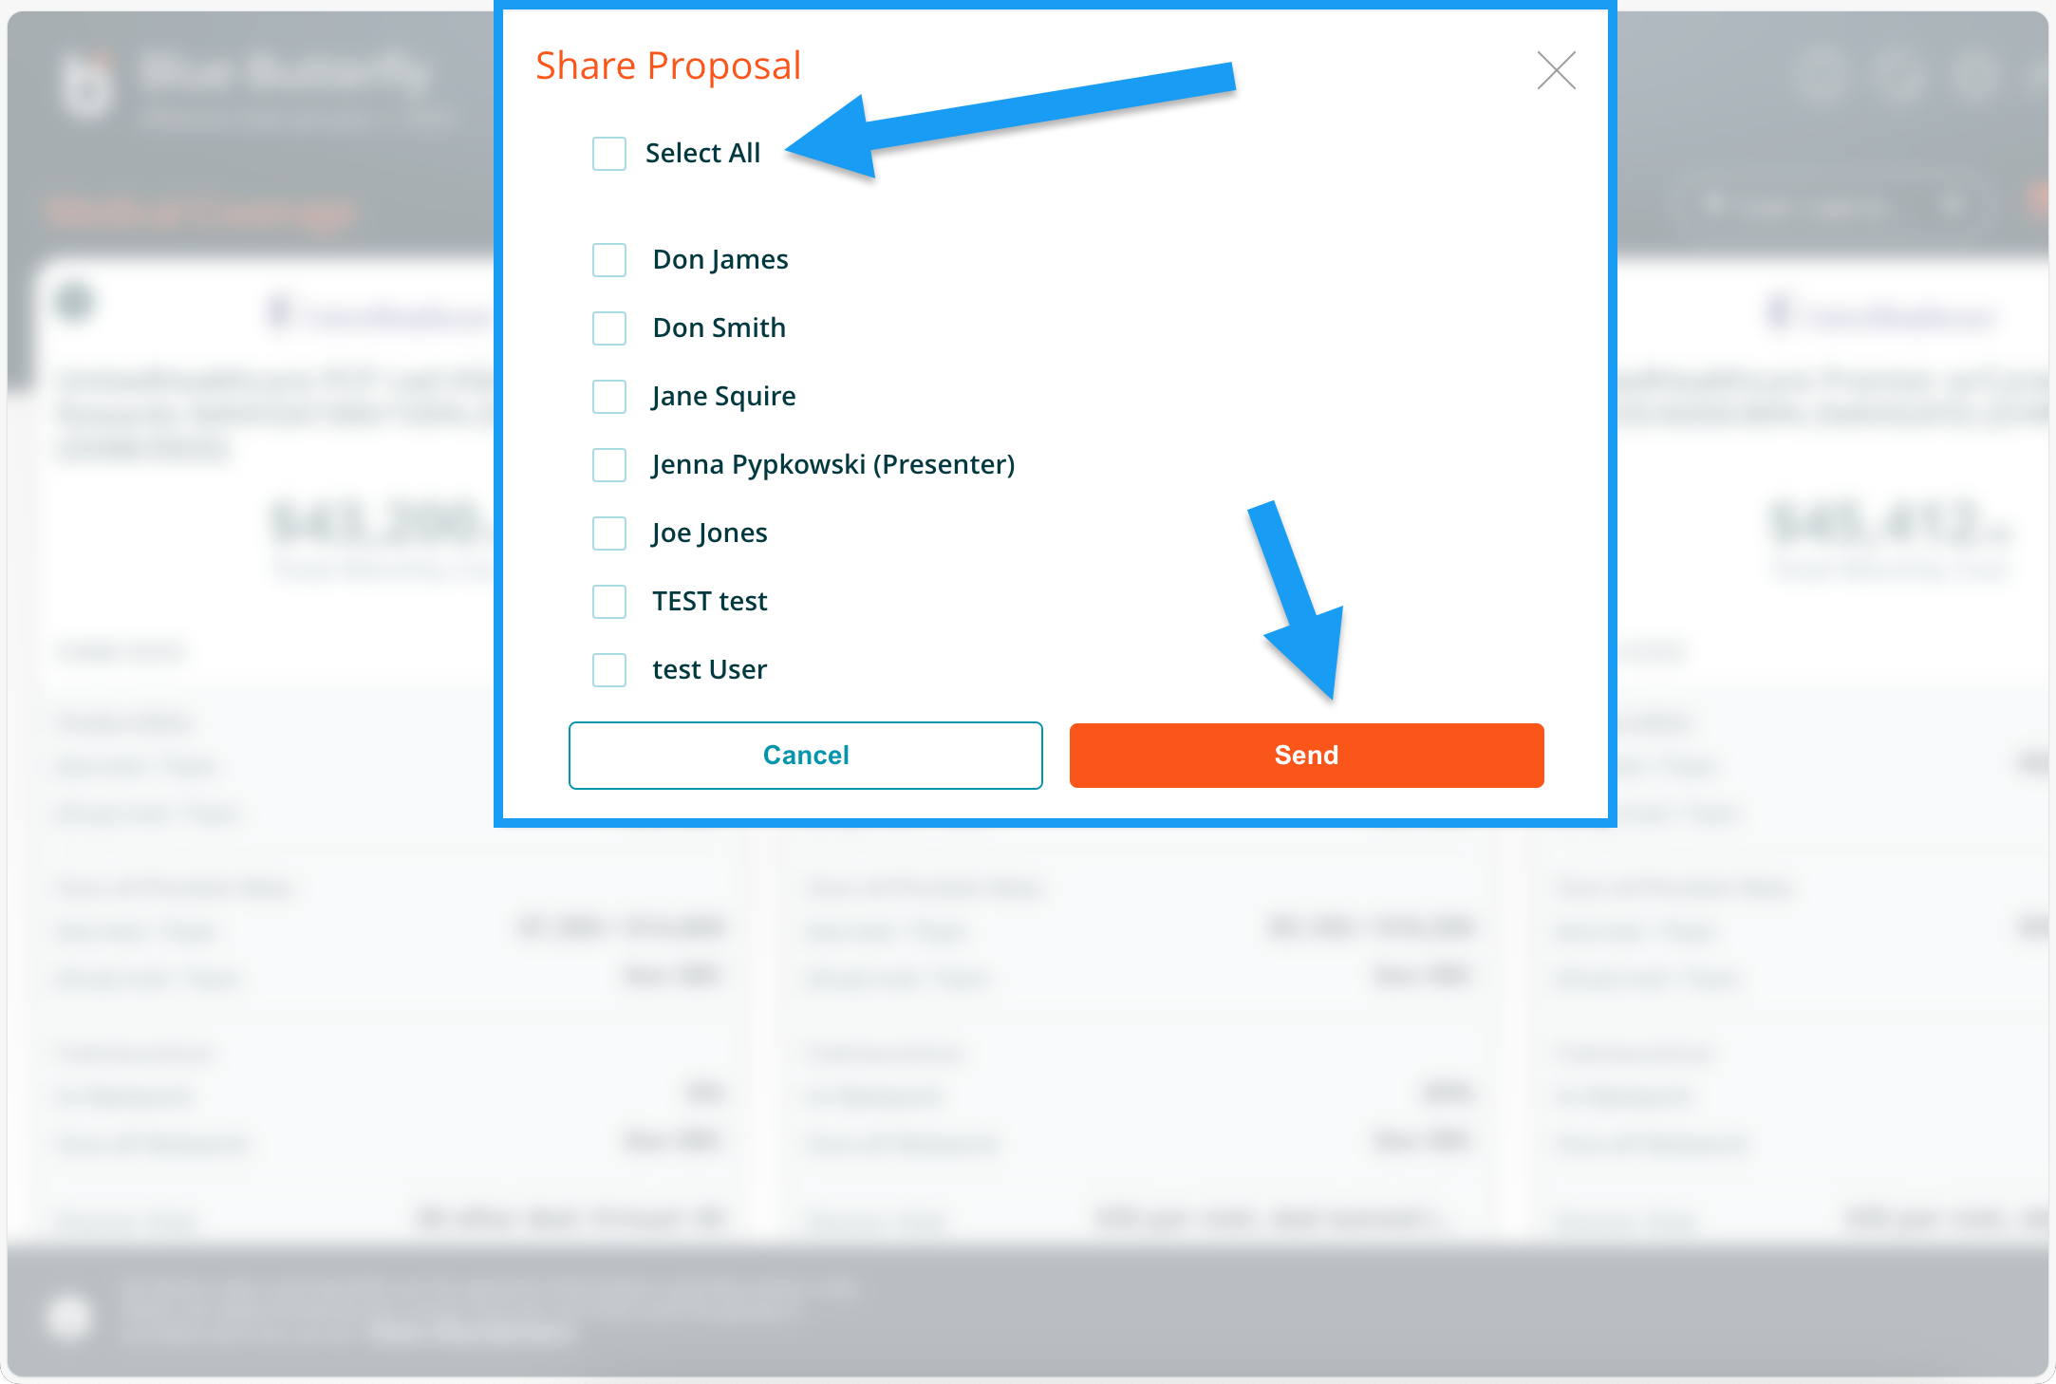

Need to share a proposal with your entire agency? We’ve made it

simple! The Share Proposal feature now includes a convenient Select All checkbox. With just one click, you can ensure the proposal reaches everyone in your agency— saving time and keeping your team aligned.

[**Learn more**](https://help.benefitter.com/distribute-proposal/)

# Check out what’s coming:

**Good News for Nevada Brokers!**

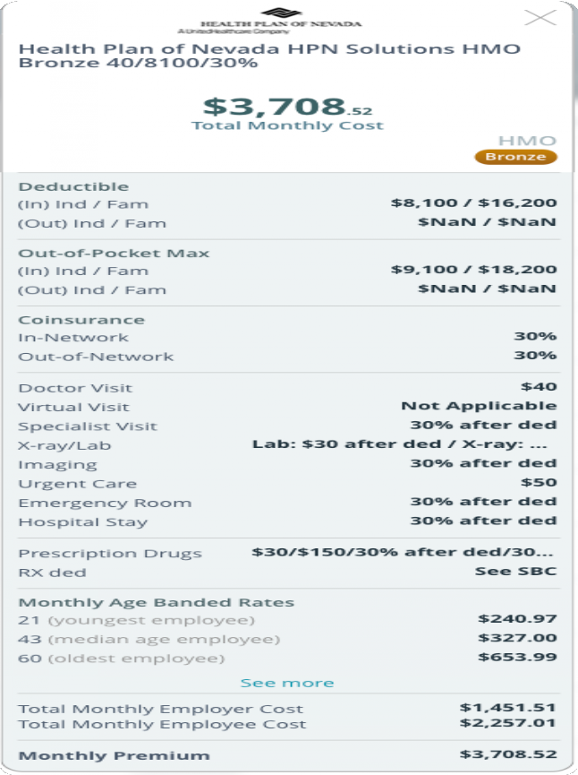

This week, we’re launching a new feature that streamlines the policy installation process for **Sierra Health and Life** and **Health Plan of Nevada**. Brokers working with groups sized 2-50 can now quote and enroll policies directly on our platform—no more jumping between carrier websites. It’s seamless, integrated, and works just like Benefitter’s current installation process for fully insured products.

# Even more Level Funded Products!

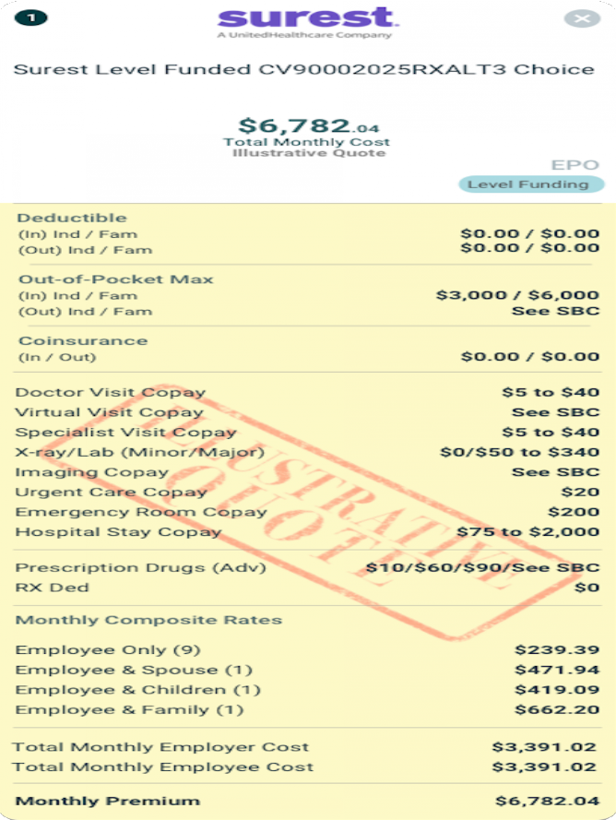

Surest is a level funded health plan with an innovative plan design and member experience created to meet the diverse needs of your clients. Using the Surest app or website, members see actual copays - not estimates

- in advance of making an appointment with access to the broad, nationwide UnitedHealthcare provider network. Plus, employers saved 15% on average, and members saved 54% on out- of-pocket costs.

# Vertical Excel: The Ultimate Benefits Breakdown.

Looking for a clear and easy way to view your client’s benefits? Vertical

Excel is here! It combines the clean look of our PDF card view but in a handy Excel format. With carriers listed horizontally and benefits listed vertically, you can quickly compare plans and make data-driven decisions.

[**Learn more**](https://help.benefitter.com/distribute-proposal/)

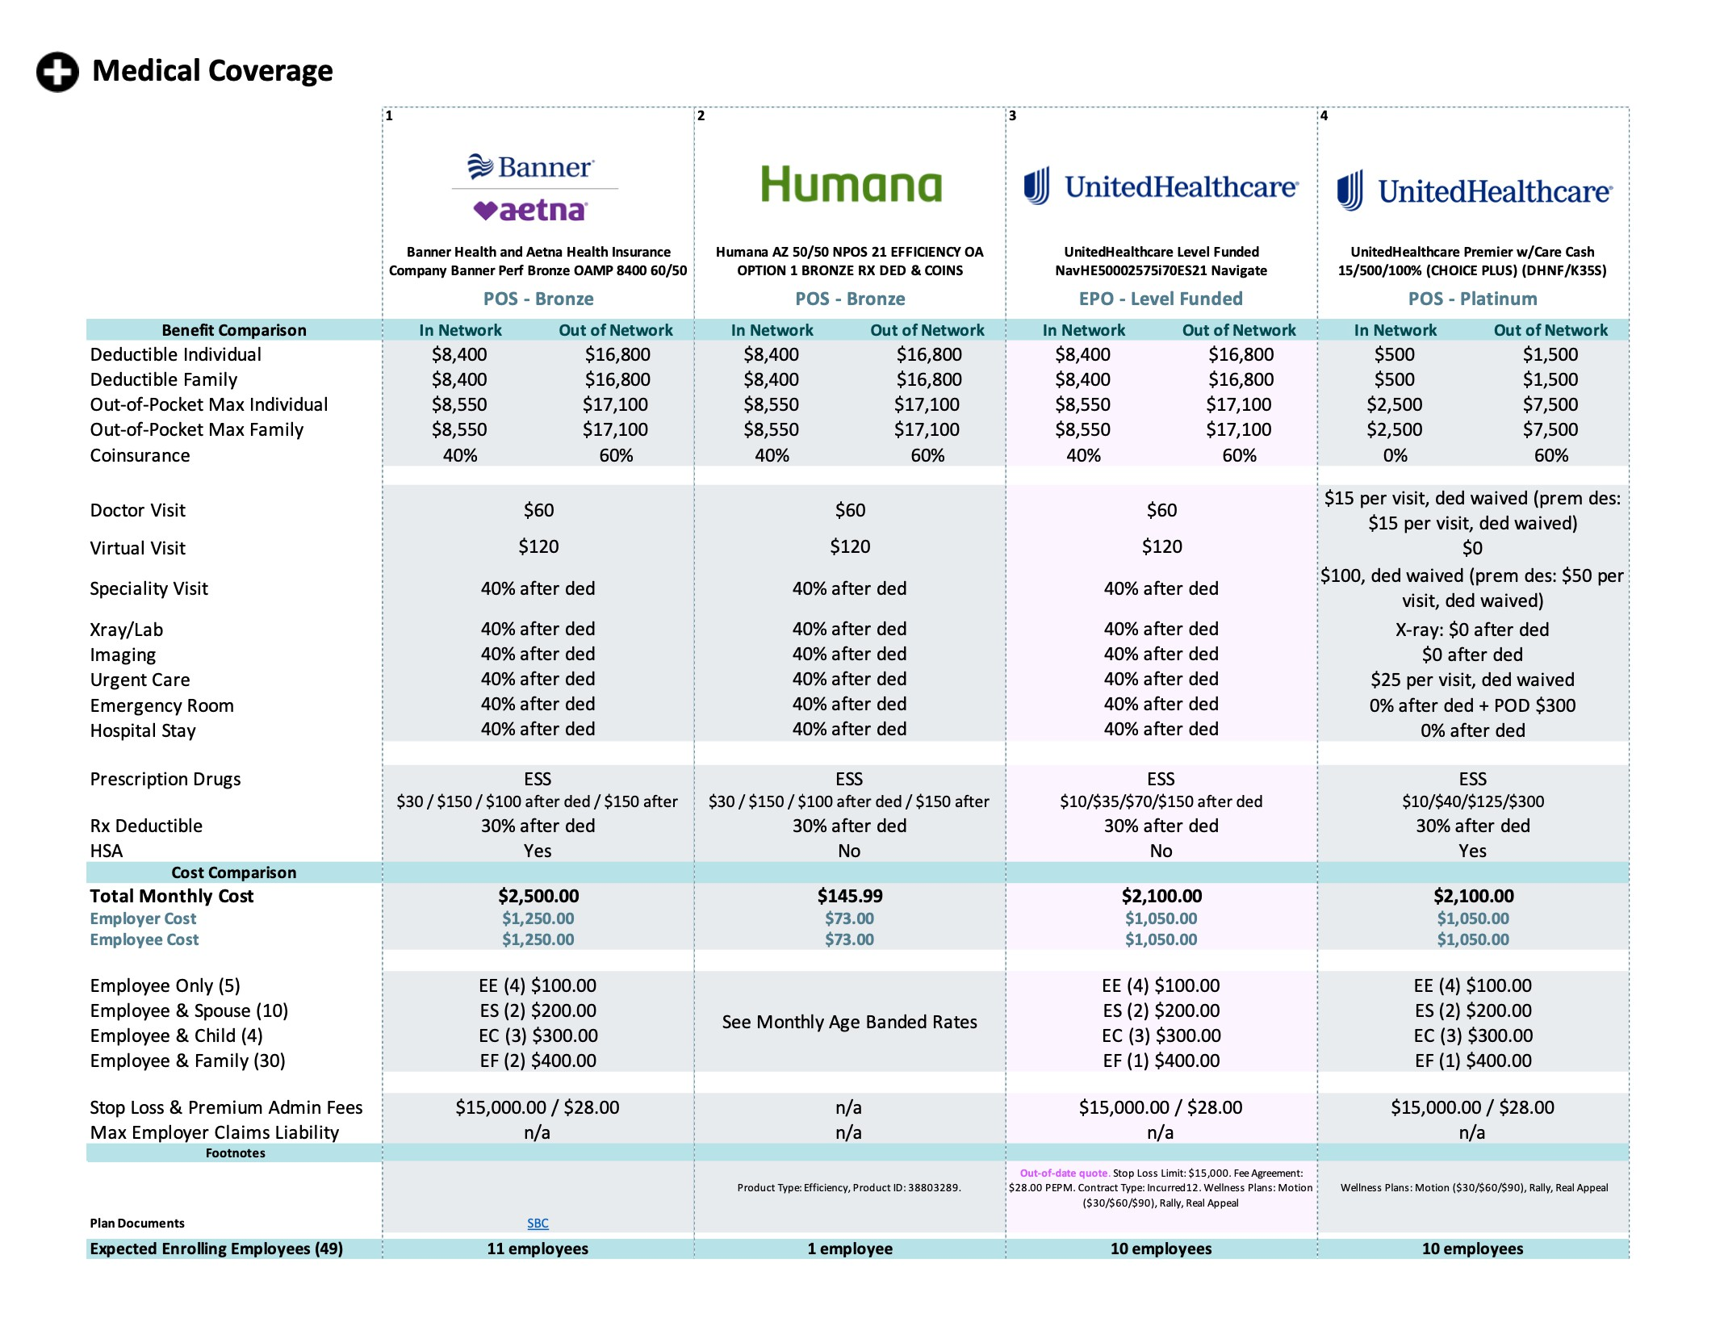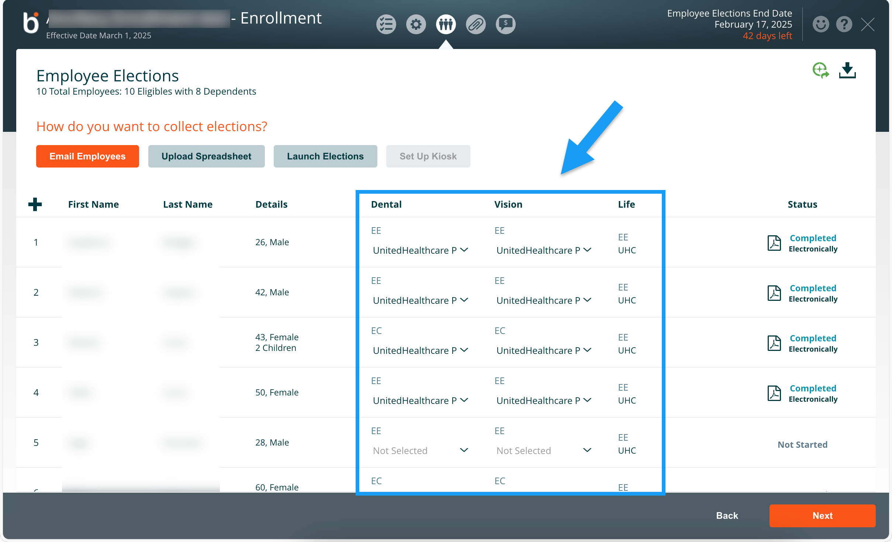

# Specialty Only Enrollments: Easier Than ever.

Now, brokers can electronically install cases for groups with just UHC

specialty lines of coverage—think dental, vision, and life—without needing to include medical coverage. This streamlined option makes the process faster and more flexible for your clients.

[**Learn more**](https://help.benefitter.com/quick-start-guide-enrollment/)

# Plan Updates at Enrollment.

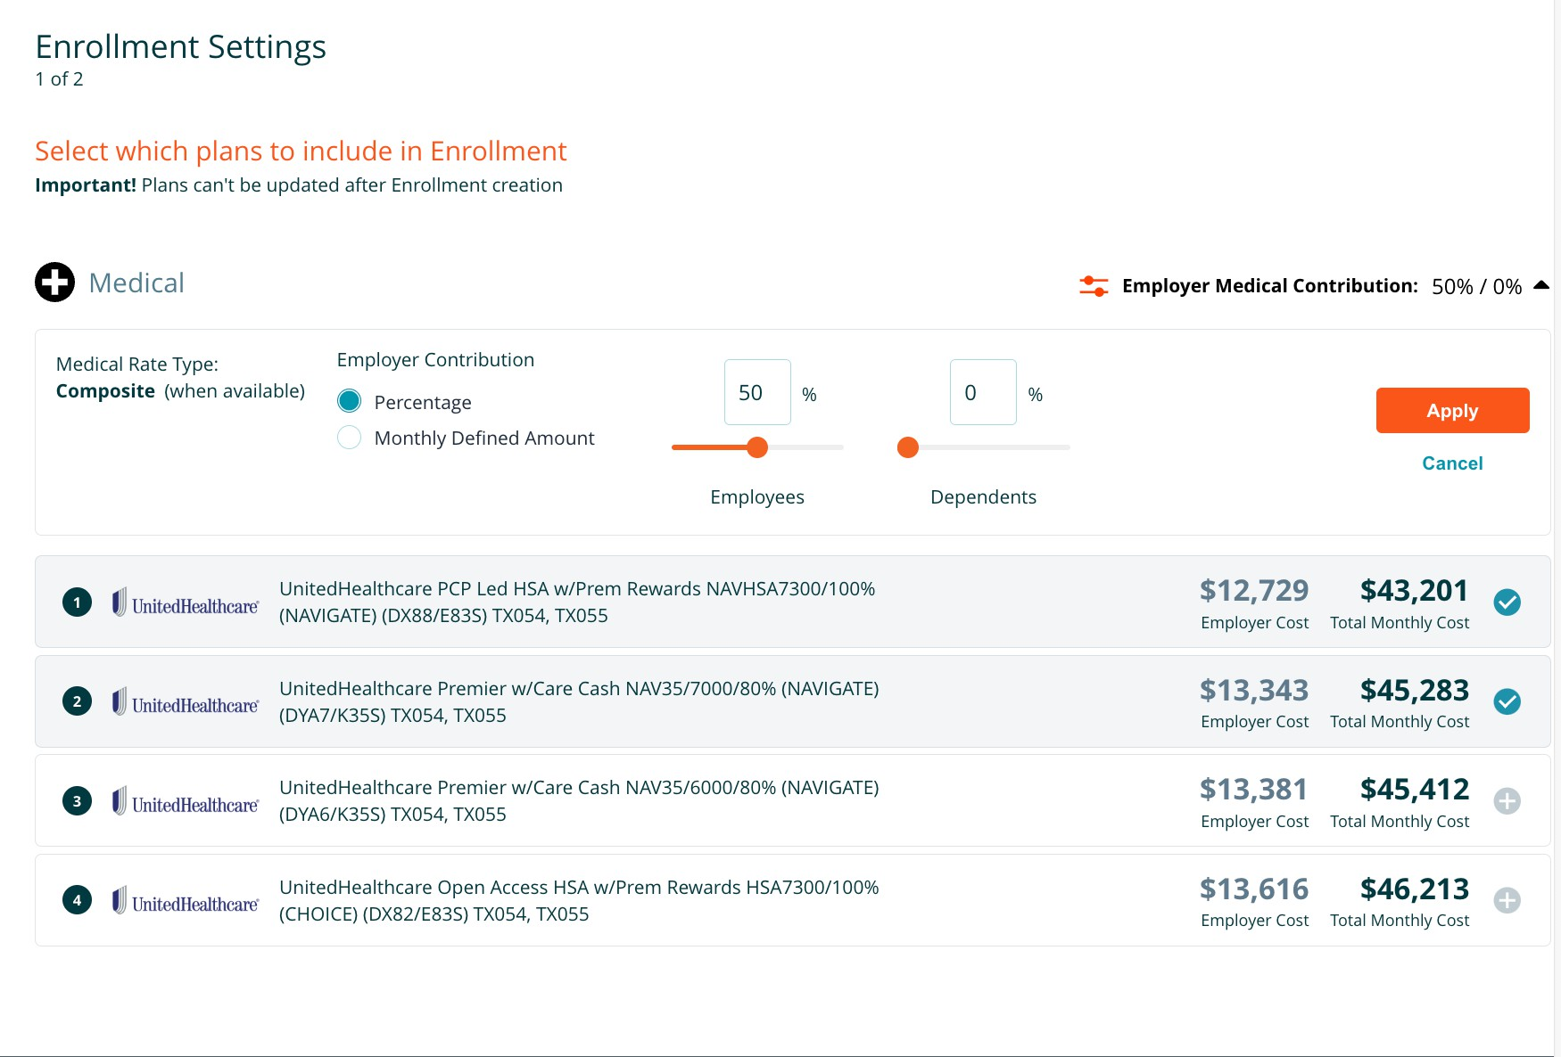

This new feature lets users add new plans directly to an existing

Enrollment. Previously, users had to delete the Enrollment, go back to the proposal, add new plans, and create a new Enrollment. Now, they can simply add compatible plans to the existing Enrollment, saving time and effort.

[**Learn more**](https://help.benefitter.com/quick-start-guide-enrollment/)

# Voluntary & Contributory Specialty plans.

Users can now toggle a setting during quoting to display both

Voluntary and Contributory Specialty plans simultaneously. This new feature works with Dental and Vision products, allowing users to add both plan types to the same proposal on the Selected Plans page.

[**Learn more**](https://help.benefitter.com/adjust-rates-contribution-level-funded/)

We’re committed to making your work more efficient and your client relationships stronger. Stay tuned for even more updates and keep using these new features to stay ahead of the game.

# Stay Informed:

[**Help Center**](https://help.benefitter.com/)

Access a wide range of resources including detailed step-by-step instruction guides and FAQs to help you make the most of our platform on our Help Center.

[**Submit Ticket**](https://help.benefitter.com/contact-us/)

Live support is available to assist you Monday- Friday, 8:00 am – 7:00 pm

Central Time at (800) 419- 0116 or send an email to [support@benefitter.com](mailto:support@benefitter.com).

[**Training**](https://help.benefitter.com/training/)

Sign up for an in-depth training on how to use Benefitter from start to finish. Learn how to create company, upload a census, quote, elect, and enroll LF and FI groups.

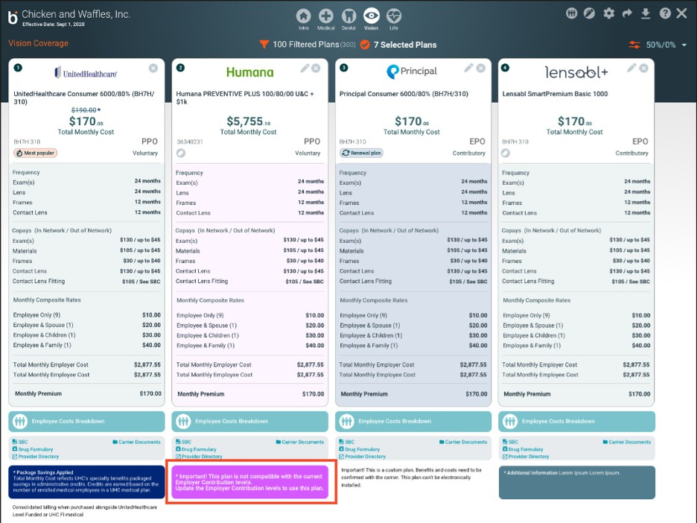

[Website](https://www.benefitter.com/) [Email](mailto:support@benefitter.com) [LinkedIn](https://www.linkedin.com/company/benefitter/)

You are receiving this email because you expressed interest in Benefitter.



Copyright © 2022 Benefitter. All rights reserved.

9151 Boulevard 26 North Richland, TX 76180

Want to change how you receive these emails?

You can [update your preferences](https://benefitter.us13.list-manage.com/profile?u=6988d60436d637c0786424e2d&id=ecd561b02f&e=%5BUNIQID%5D&c=26c77c016f) or [unsubscribe from this list](https://benefitter.us13.list-manage.com/unsubscribe?u=6988d60436d637c0786424e2d&id=ecd561b02f&t=b&e=%5BUNIQID%5D&c=26c77c016f).