**Voluntary & Contributory Specialty add both plan types to the same proposal**

Now both Voluntary and Contributory Dental and Vision Specialty plans can be displayed on the proposal during quoting. You can add both plan types to the same proposal.

**Choose the Employer contribution settings:**

Contributory=50% -100%

Voluntary=0% - 49%

Combined=Contributory & Voluntary

Compatible/Incompatible plans - display rules

* + Compatible plans

Available plans page - white ribbon label

Plan cards – white or grey background

* + Incompatible plans

Available plans page - rubine ribbon label

Selected plans page - Plan cards – rubine background & rubine ribbon message

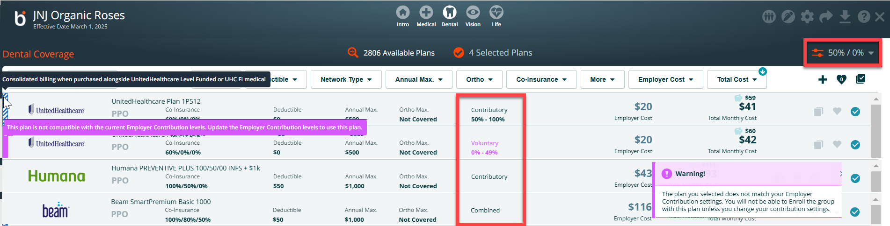

**Contribution Type column – rules on the proposal**

* + **Humana** - **Participation**

Voluntary - Less than 50% participation

Contributory - 50% or greater participation

* + **UHC** – **Employer Contribution range rules on the proposal**

Voluntary (0% – 49%)

Contributory (50% – 100%)

* + **Anthem, Avesis, BCBS MN and Beam** - **ER Contribution range on the proposal**

Combined – (0% – 100%)

If you add a plan to the proposal that does not match the employer contribution, you will see a warning message on the proposal. The display shows ‘The plan you selected does not match your employer contribution settings. You will **not be** able to enroll the group with this plan unless you change your contribution settings’.

**Enrollment Settings – restricted plan rules**

* + **Plan selection restriction message**

Humana - plans must meet participation rules

UHC - plans must match ER Contribution range

Anthem, Avesis, BCBS MN and Beam – no ER Contribution or Participation rules

**Enrollment Settings** – In the example below,the plan cannot be added to the enrollment, because the plan is not compatible with the current Employer Contribution settings.

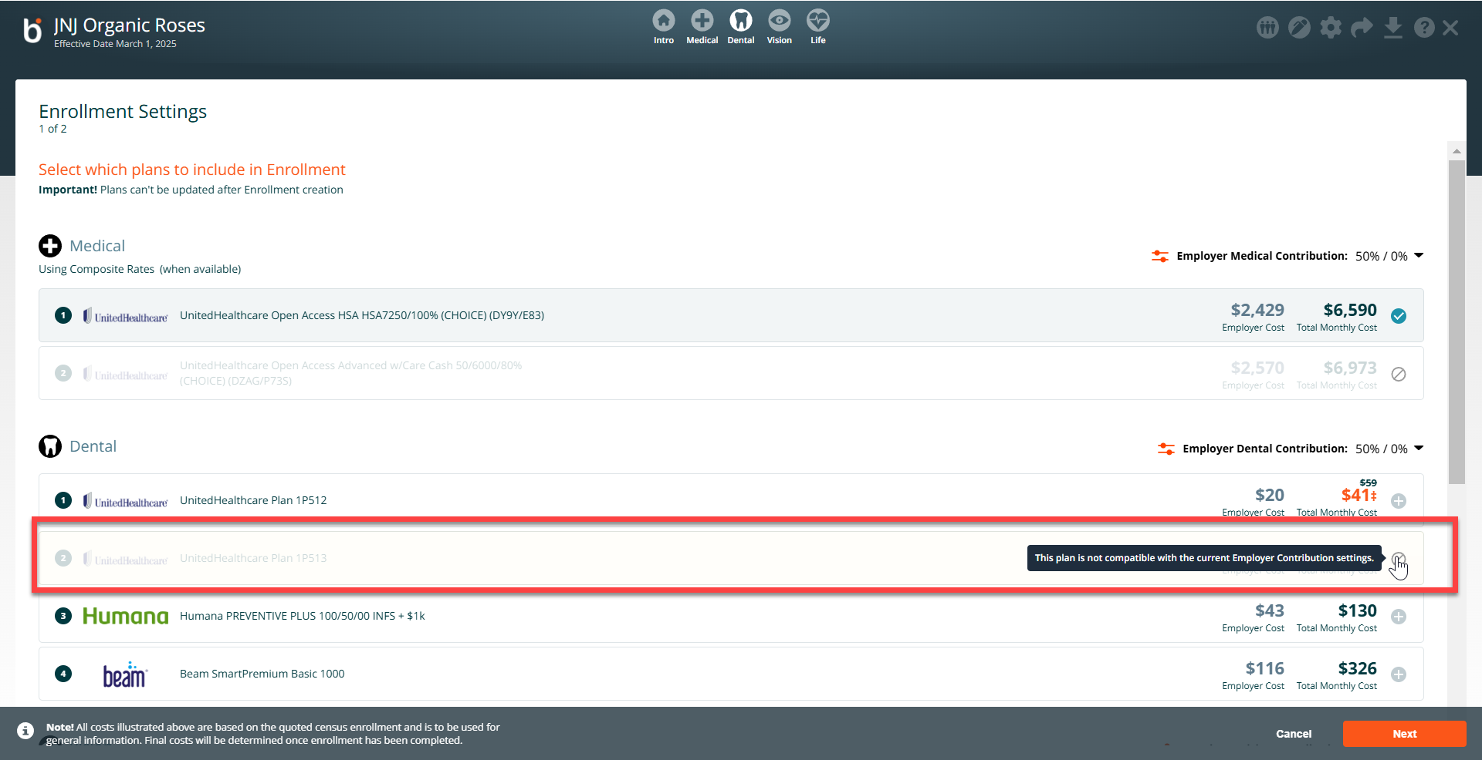

On the enrollment settings screen, if you need to modify the employer contribution percentage changes must be within range set on Proposal. If you need to change the contribution from voluntary to contributory you will need to delete the enrollment. On the proposal change employer contribution percentage range, add the plans to the proposal, then create a new Enrollment.

**Reminder:** Voluntary 0% – 49%, Contributory 50% – 100%

