NEW! Healthsafe ID (HSID)
Benefitter strives for the highest level of privacy and security. Because of this, we’re changing the way employees log in to access electronic medical questionnaires and to select plans at enrollment. If you need Support assistance setting up your HSID account, please contact HSID toll free at 1 (877) 844-4999, press 2. When the prompt asks for your member id say ‘I don’t have it’.

Step 1 Employee receives email with link and activation code
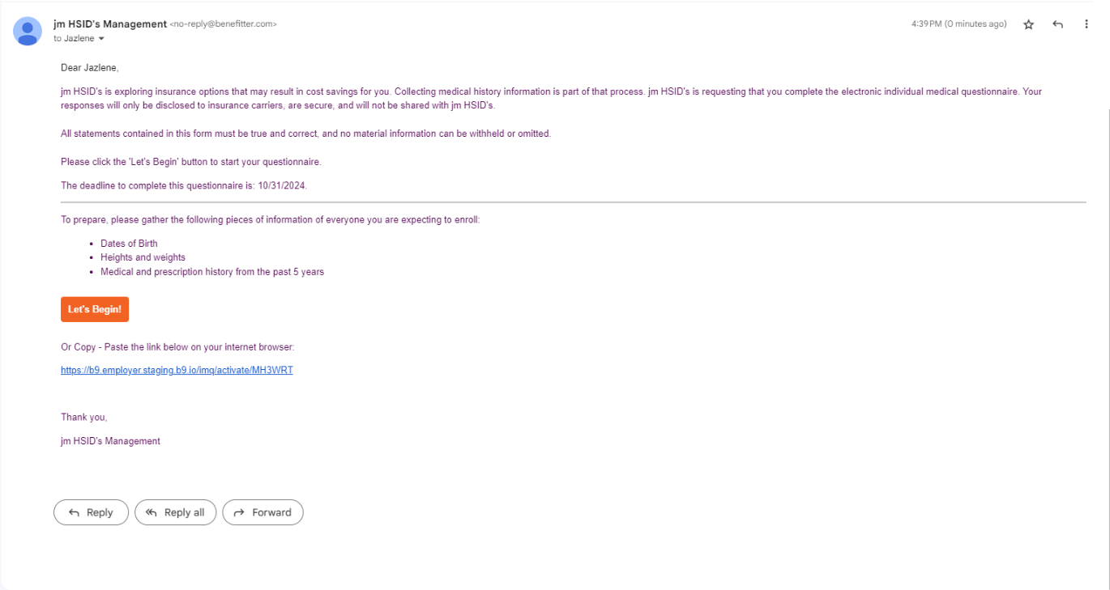

Step 2 Employee is directed to HealthSafe ID site and selects register.
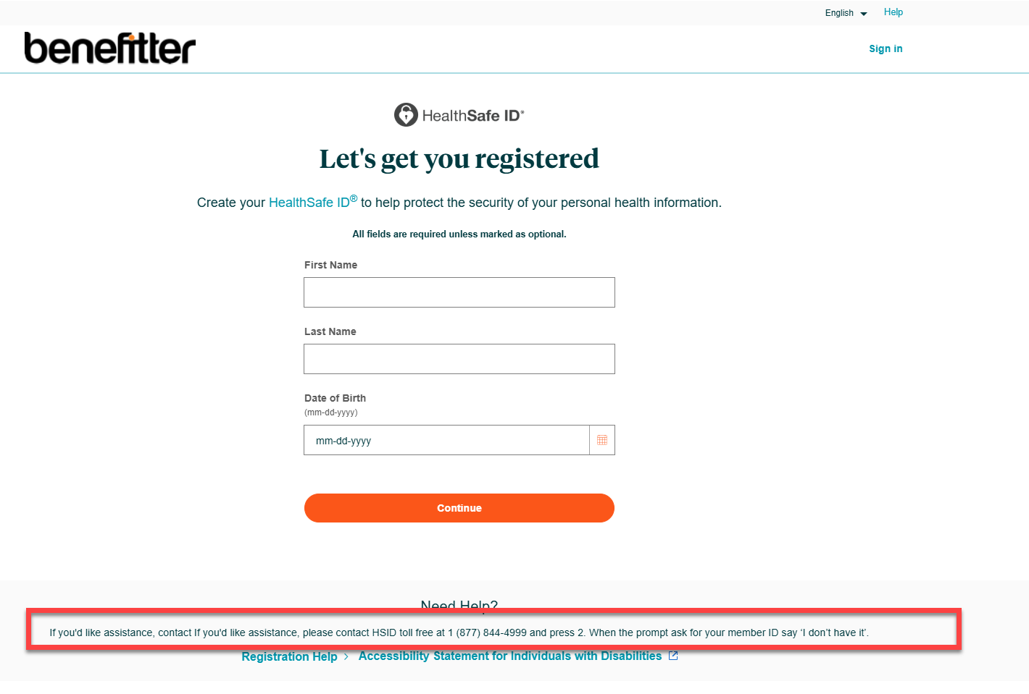

Step 3 Healthsafe ID asks for a confirmation text or phone call.
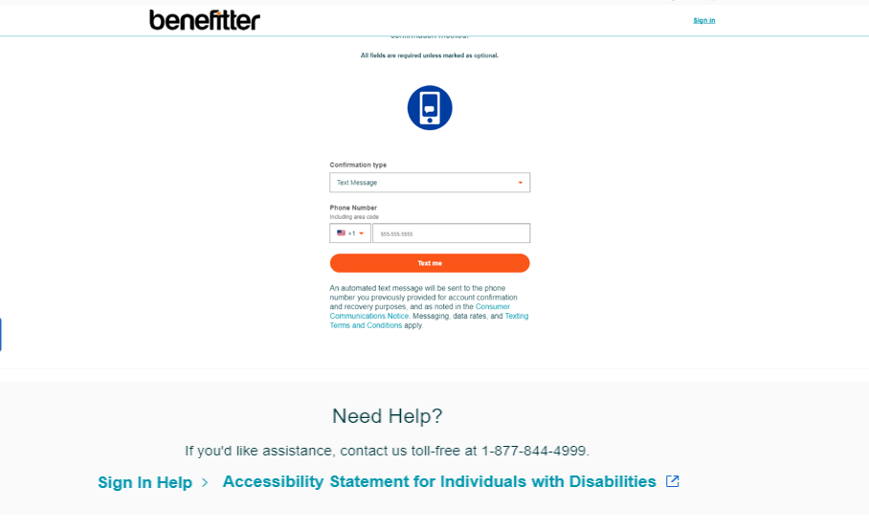

Step 4 Healthsafe ID confirms account created.
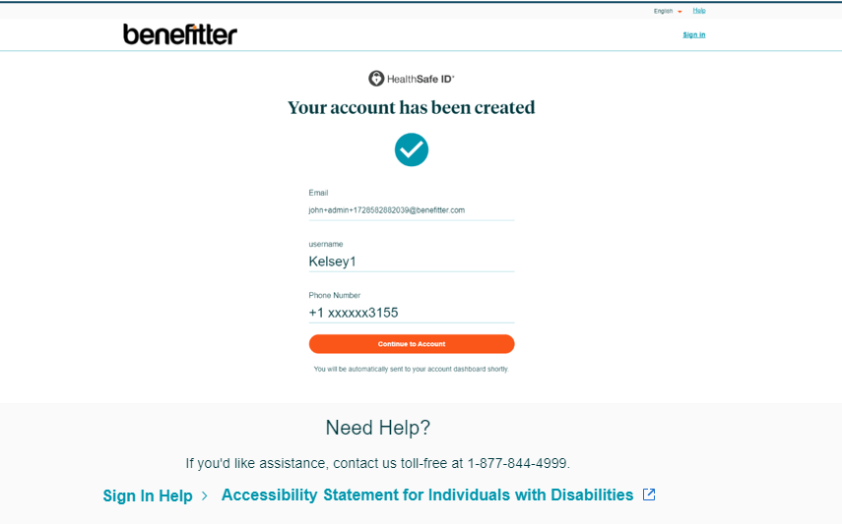

Step 5 Healthsafe ID then redirects to Benefitter’s electronic application.
IMQ
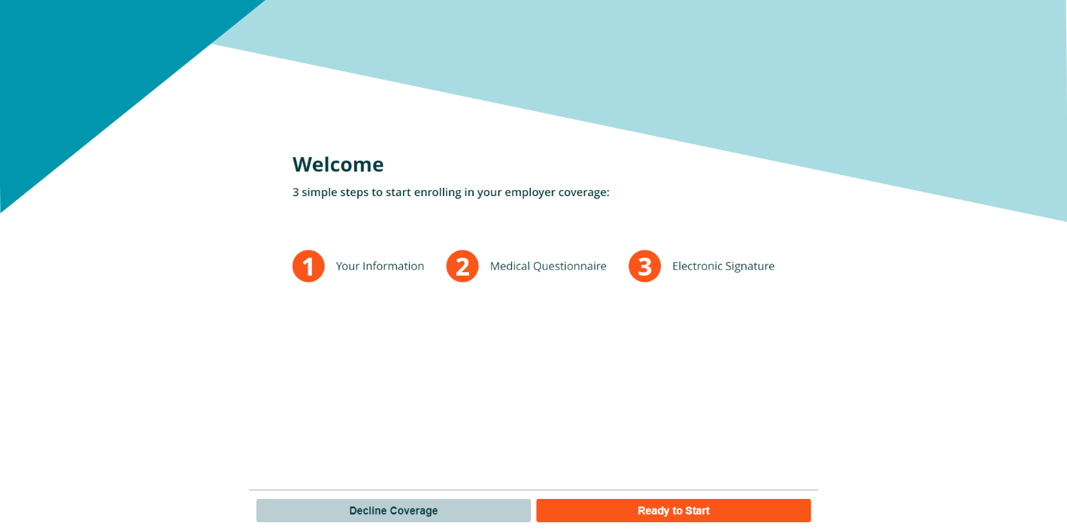

Or the Employee election screen
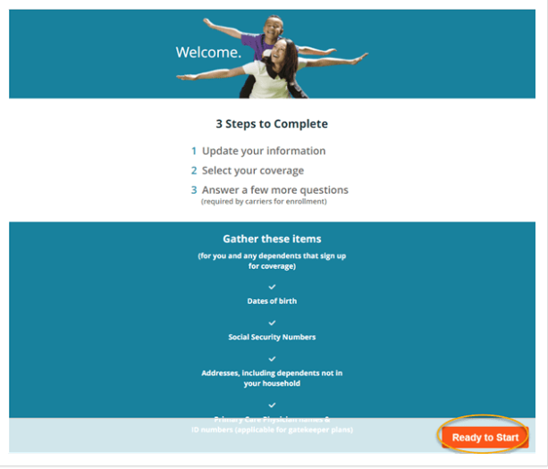

Step 6 You will receive an email to confirm your email address.
