NEW! Healthsafe ID (HSID)
Benefitter strives for the highest level of privacy and security. Because of this, we’re changing the way employees log in to access electronic medical questionnaires and to select plans at enrollment. If you need Support assistance setting up your HSID account, please contact HSID toll free at 1 (877) 844-4999, press 2. When the prompt asks for your member id say ‘I don’t have it’.

Step 1 Employee receives email with link and activation code
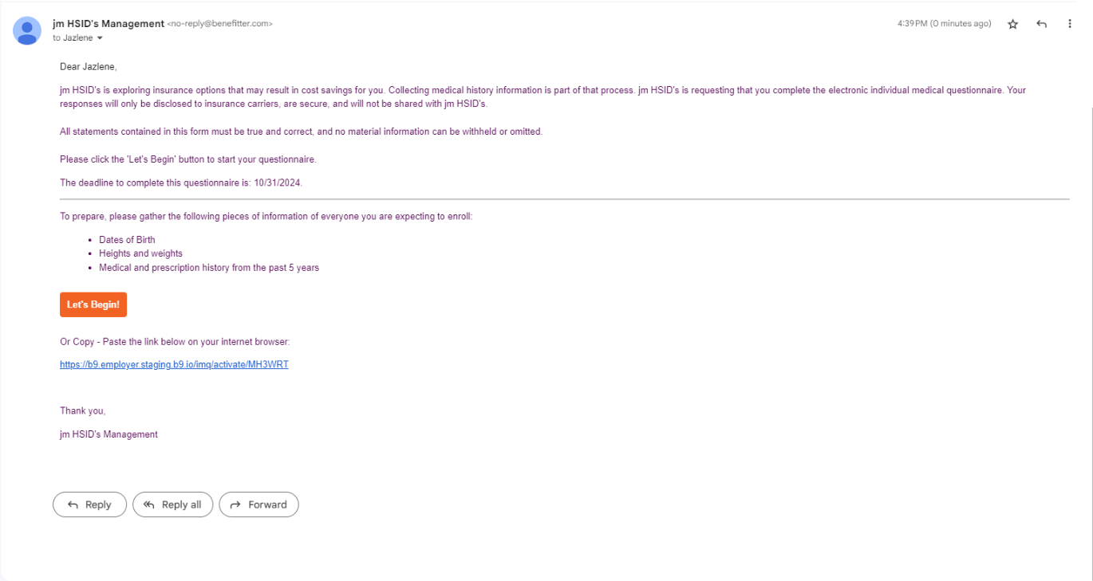
Step 2 The Employee is directed to the HealthSafe ID site to create an account.
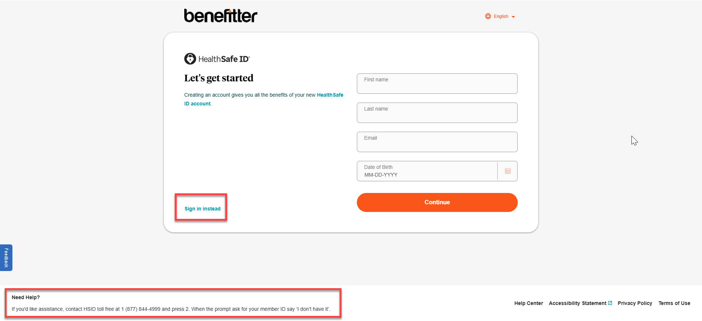
The need help? Message is displayed on the bottom left side of the page advising ‘If you need Support assistance setting up your HSID account, please contact HSID toll free at 1 (877) 844-4999, press 2. When the prompt asks for your member id say ‘I don’t have it’.

Step 3 Healthsafe ID requires a confirmation text or phone call.
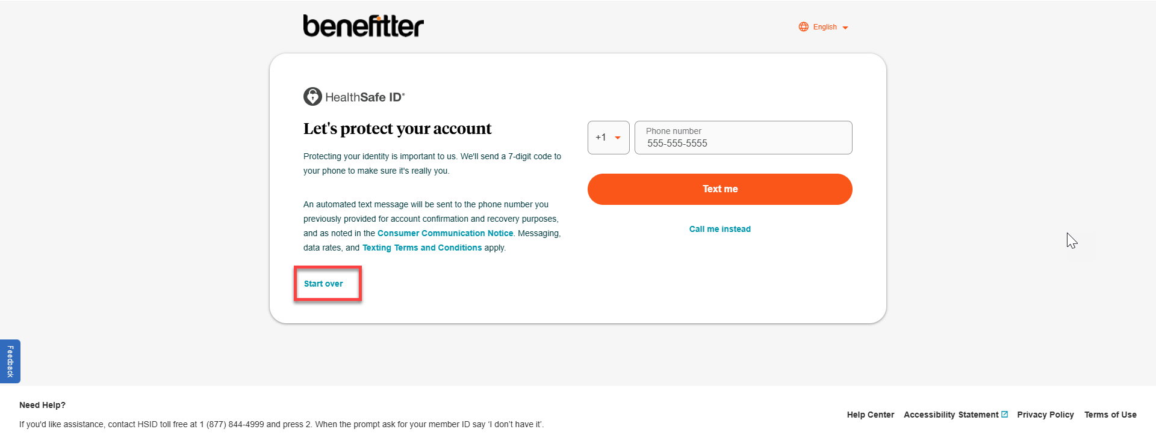
Step 4 The employee will need to enter the code sent via text message and press continue.
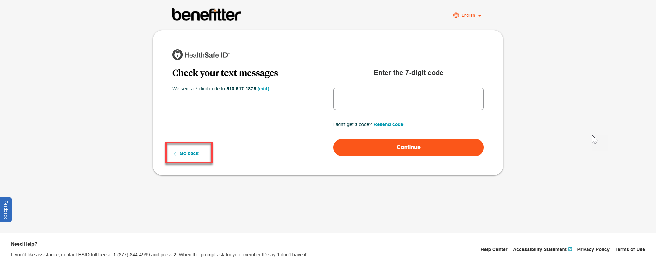
Step 5 The employee will need to a create password, click on the link to review the terms of service and, check the box to confirm reviewing the terms of service.
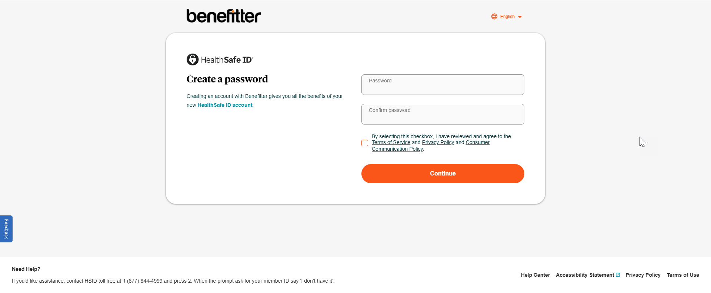

Step 6 The employee will be redirected to the confirmation page that shows the account has been created. Press continue.
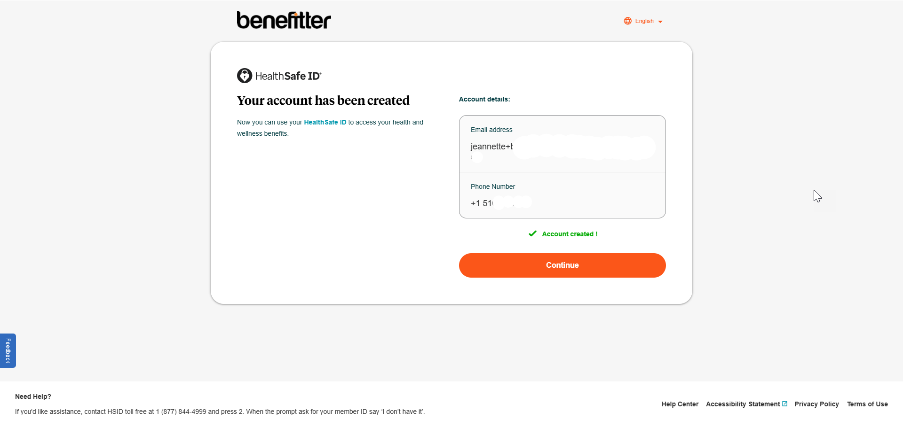

Step 7 Healthsafe ID then redirects to Benefitter’s electronic application so the employee can complete their IMQ or enrollment.
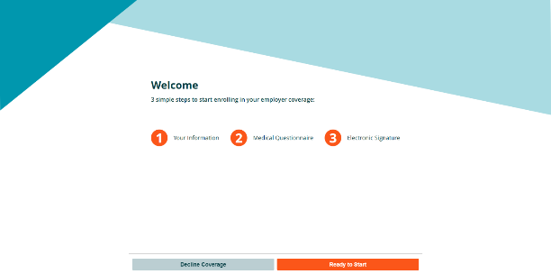
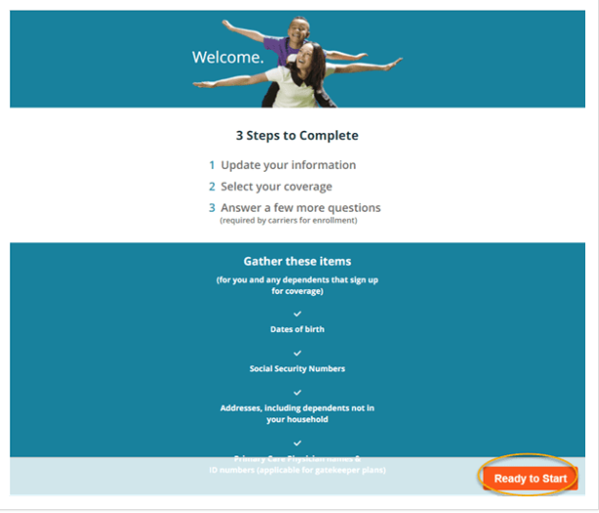

Step 8 After completing the IMQ or enrollment if the employee needs to update their application click on the let’s begin button in the email notifcation. If your employee uses the kiosk pdf that has an activation code on the computer provided by the employer. Or enter the URL on the PDF sheet on any internet connected device. Click the on the Sign in instead link.
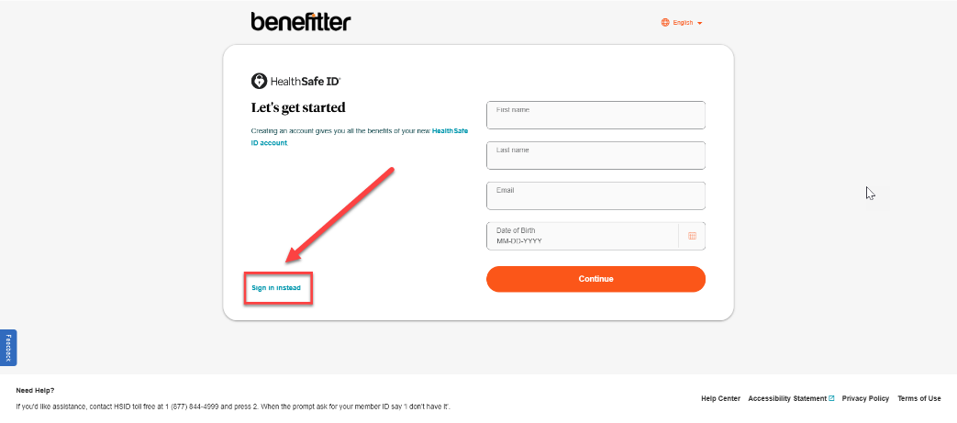

The employee can sign into their account. 