Benefitter – Voluntary & Contributory Specialty plans on same proposal
Description
During quoting, on the Available Plans page, users will now see Voluntary, Contributory and ‡Combined specialty plans simultaneously by default. All three plan types can now be added to the same proposal. Additionally, plan lookups can be refined by using the new contribution filter to narrow search results by plan type.
A rubine warning label tells users which plans are incompatible with the current Employer Contribution percentage so users can easily distinguish them from compatible plans.
New Features
QUOTING
Available Plans page
- All Voluntary, Contributory and Combined plans are displayed at the same time by default and can be added to the same proposal.
- New side panel ribbons indicate which plans are compatible with the current ER Contribution %.
  - Solid white and stripped ribbons - plans are compatible.
  - Rubine ribbon - plans are incompatible.
- Plan tiles have new badge labels that indicate if the plan is Voluntary, Contributory or Combined.
- New Contribution filters allow users to narrow their search results by:
  - Voluntary
  - Contributory
  - Combined (Anthem, Avesis, BCBS MN and Beam).
- Messaging:
Tool tips - incompatible plans: (1) hovering over the select button. (2) hovering over the Rubine side panel ribbon.
(1) “This plan is not compatible with the current Employer Contribution levels.”
(2) “This plan is not compatible with the current Employer Contribution levels. Update the Employer Contribution levels to use this plan.”
Toast message - when incompatible plans are selected:
“The plan you selected does not match your Employer Contribution settings. You will not be able to Enroll the group with this plan unless you change your contribution settings.”
Selected Plans page
- Incompatible plan cards have a rubine background color plus a rubine warning message in the footer section:
“Important! This plan is not compatible with the current Employer Contribution levels. Update the Employer Contribution levels to use this plan.”
ENROLLMENT
Enrollment Settings page
- Plan compatibility is enforced during plan selection.
United Healthcare rules
  - Can only select plans that match the ER Contribution %.
  - ER Contribution % changes are limited and can only be adjusted to a percentage within the current range. (ex. for a Voluntary plan the % can only be adjusted between 0 – 49%.)
  - To select plans that match the opposing ER Contribution percentage, the user must return to the Proposal page and update the Contribution % and then begin a new Enrollment.
Humana rules
  - Less than 50% enrolled then only Voluntary plans can be enrolled.
  - Greater than 50% enrolled both Voluntary and Contributory plans can be enrolled.
Anthem, Avesis, BCBS MN and Beam rules (Combined plan type)
  - No Participation rules.
  - ER Contribution % changes are not restricted – can be any value between 0 – 100%.

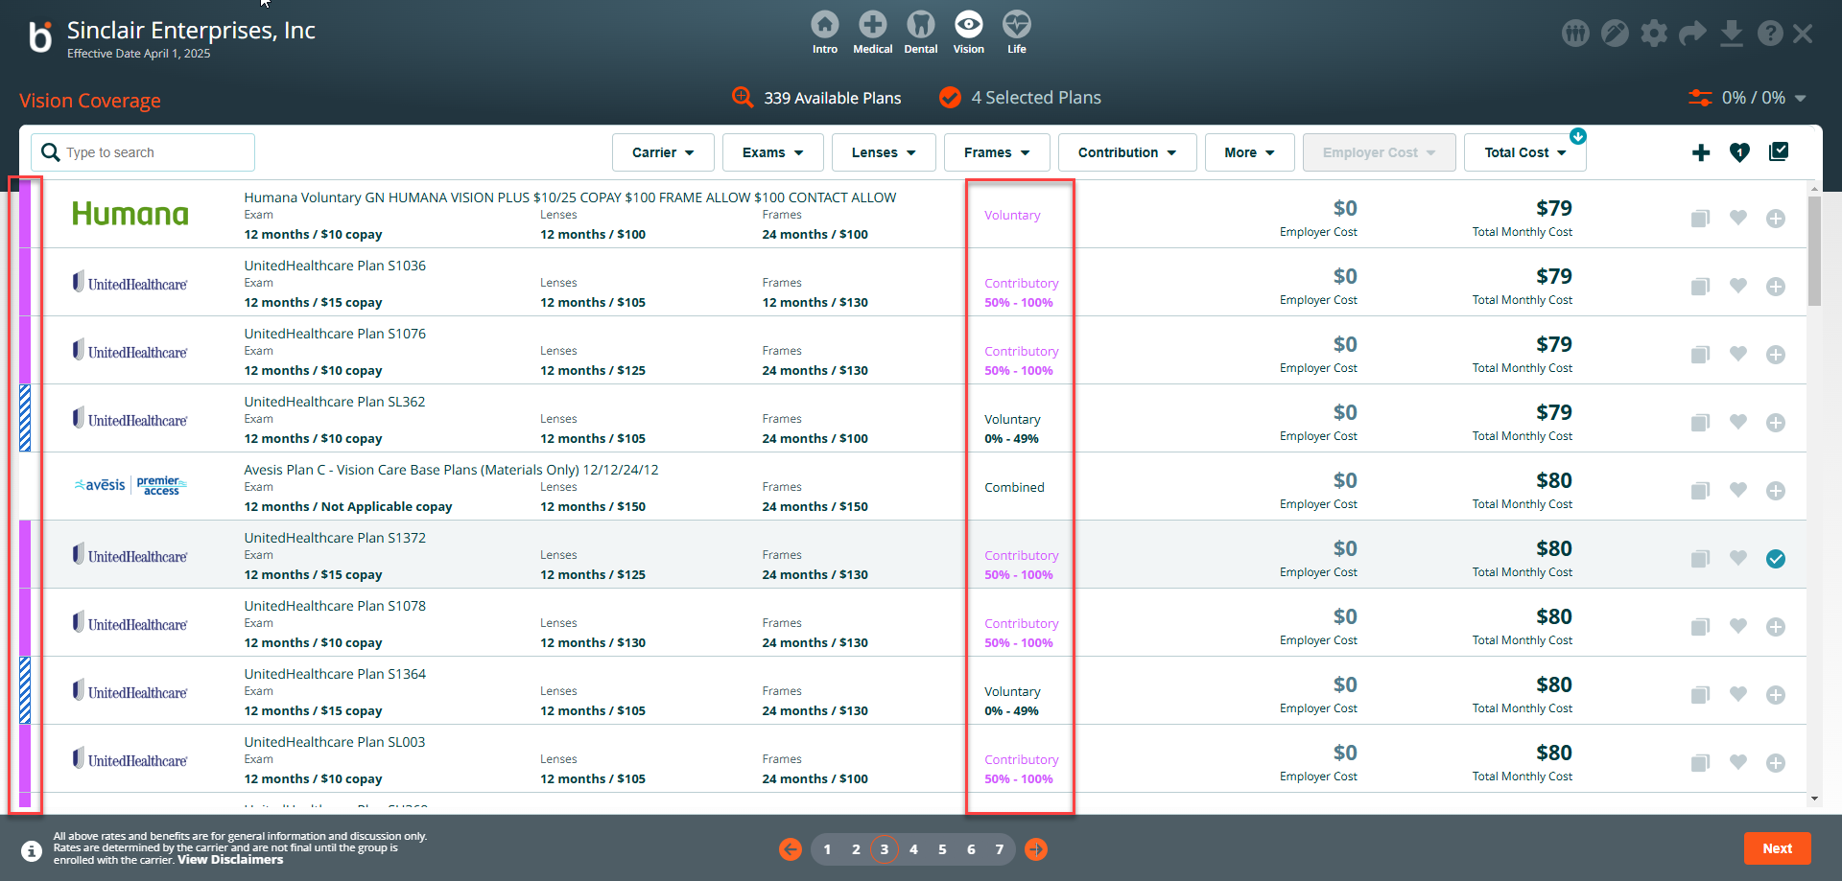

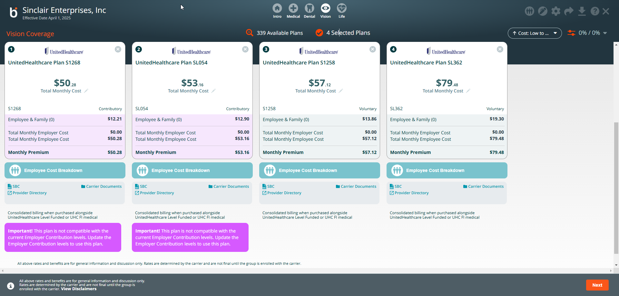

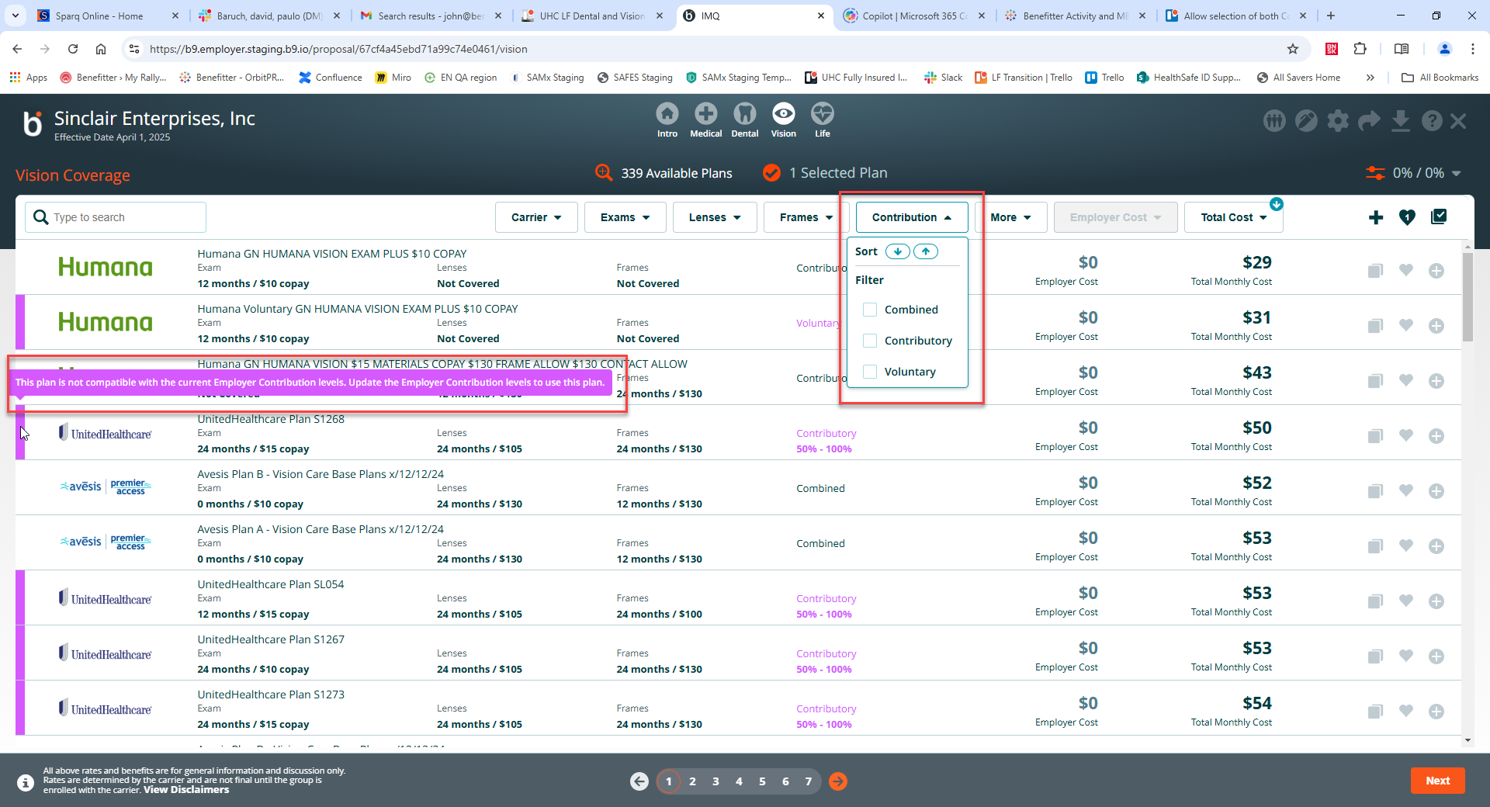

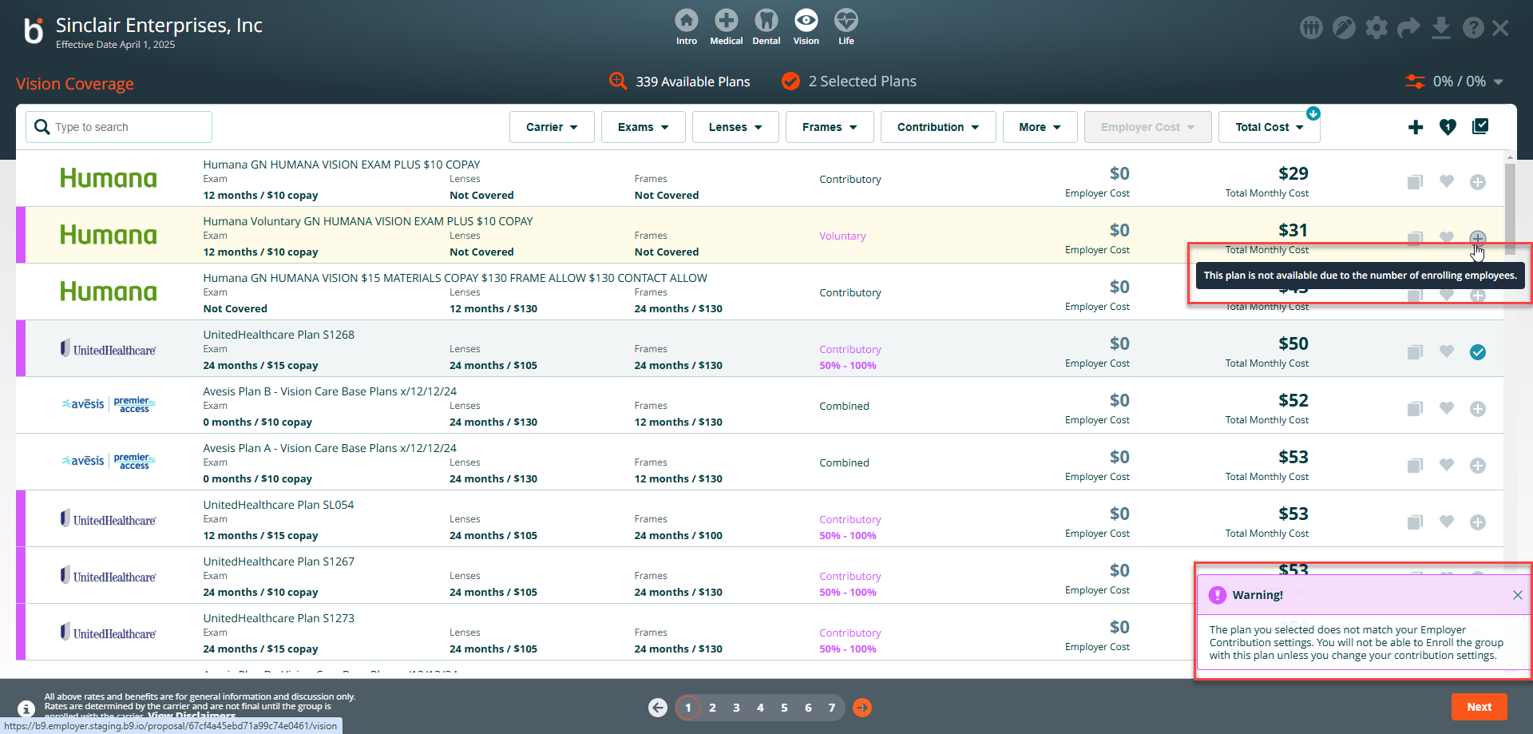

‡ Combined specialty plans - ER Contribution percentage can be any value between 0 -100%

